# Insignificant Surfaces

# *Cinema, Systems, and Embodiment*

by Colin Clark

A thesis screening presented to OCAD University in partial fulfillment of the requirements for the degree of Master of Fine Arts in Interdisciplinary Masters in Art, Media, and Design

Arraymusic Studio, 155 Walnut Ave., Toronto

March 18, 2016

Toronto, Ontario, Canada, April 2016

c Colin Clark, 2016

This work is licensed under a Creative Commons Attribution 4.0 International license. To see the license, go to <https://creativecommons.org/licenses/by/4.0/legalcode>

# Copyright Notice

This document is copyright Colin Clark, 2016 and is licensed under a Creative Commons Attribution 4.0 International License.

**You are free to:**

* **Share** — copy and redistribute the material in any medium or format
* **Adapt** — remix, transform, and build upon the material

for any purpose, even commercially. The licensor cannot revoke these freedoms as long as you follow the license terms.

**Under the following terms:**

* **Attribution** — You must give appropriate credit, provide a link to the license, and indicate if changes were made. You may do so in any reasonable manner, but not in any way that suggests the licensor endorses you or your use.

**No additional restrictions** — You may not apply legal terms or technological measures that legally restrict others from doing anything the license permits.

**Notices:**

You do not have to comply with the license for elements of the material in the public domain or where your use is permitted by an applicable exception or limitation.

No warranties are given. The license may not give you all of the permissions necessary for your intended use. For example, other rights such as publicity, privacy, or moral rights may limit how you use the material.

The full text of this license is available on the web at: http://creativecommons.org/licenses/by/4.0/legalcode

# Author’s Declaration

I hereby declare that I am the sole author of this thesis. This is a true copy of the thesis as accepted by my examiners.

I authorize OCAD University to lend this thesis to other institutions or individuals for the purpose of scholarly research.

I understand that my thesis may be made electronically available to the public, under the terms of the Creative Commons license above.

I further authorize OCAD University to reproduce, also under the terms of the license, this thesis by photocopying or other means, in total or in part, at the request of other institutions or individuals for the purpose of scholarly research.

# Abstract

Insignificant Surfaces: Cinema, Systems, and Embodiment

Interdisciplinary Masters in Art, Media and Design

Master of Fine Art, 2016

Colin Clark

OCAD University

*Insignificant Surfaces* explores the creative and theoretical relationships amongst computation, cinema, and sound in my artistic and design practice. I propose an alternative framework for digital practice in which software and cinema are understood not solely as immaterial and informatic, but also as distinctly material, energetic, and embodied forces. Employing my own practice-inclusive research methods of *adjacency* and *lensing*, I explore the complex networks of influence that are possible amongst works of art, active viewers, and technological apparatuses. I call for a new mode of open community-based software development, *computational materiality,* which supports the ongoing, serendipitous, and unexpected creative modification of shared software artefacts. Using the theories of McKenzie Wark, Bruno Latour, Reza Negarestani, and others, and the artwork of Stan Brakhage, Chris Welsby, and Ernie Gehr, I explore the ways in which my cinema and sound can be understood within a framework of energetics, transformational ecologies, and material closure.

**Keywords**: experimental film, video, software studies, sound, interdisciplinarity

# Acknowledgements

This thesis simply would not exist without the support, help, and involvement of many people; I am incredibly fortunate to have such a remarkable community of designers, artists, and scholars around me. In particular, I would like to thank:

* Antranig Basman, whose constant intellectual companionship kept me focused and inspired, and whose revolutionary ideas form the foundation of this entire project.
* Jutta Treviranusand my colleagues at the Inclusive Design Research Centre, who believed that this was valuable to our research efforts, who supported my unpredictable work hours while I read and wrote, and who listened patiently as I worked through half-baked ideas, openly sharing their thoughts and critiques.
* David Cecchetto, who continually reminded me that criticality also demands generosity—to an idea, to a text, and to a community of thinkers.
* Izabella Pruska-Oldenhof, who exemplifies a creative scholarship of spiralling associations and constant curiosity.
* Amy Twigger Holroyd, for allowing me to use her work as an analogy for my own, and for generously sharing her thoughts on materiality, openness, and creative destruction.
* My advisors, Adam Tindale and Stan Krzyzanowski, for their creative insights and scholarly advice over the past three and half years.
* And especially, Darcie Clark, who sacrificed so much to allow me to take on too much all at once, and who patiently and lovingly supported me every step of the way.

# Dedication

*To my mother, Rev. Dr. Diane Clark, who even in her absence reminded me that doing this was possible, and provided the model for how to do it.*

# Table of Contents

List of Figures ix

Introduction 1

Adjacency 6

Methods, Disciplines, and Interdisciplinarity 6

Methods in Practice 18

Lensing 20

Lensing as Research Method 20

The Eye Lens 23

The Hand Lens 25

The Technological Lens 27

Computational Materialism 34

The Materials of Community 34

Material Artefacts 38

Material Change 40

Artifactual Materiality in Practice 44

The Material Commons 49

Material Systems: Font Màgica, Chris Welsby, and Tofino 52

In Passing: Energy, Duration, and Embodiment 59

Conclusion 69

Works Cited 72

Appendix A: Screening Programme Notes 81

# List of Figures

Figure 1: Video still from Everything is awake! 26

Figure 2: Reknitted cardigan by Amy Twigger Holroyd 42

Figure 3: Example of a declarative Flocking program 47

Figure 4: Diagram of the meta-level structure of *Font Màgica* 48

Figure 5: Video still from *Tofino* 58

Figure 6: Video still from *In Passing*. 61

Figure 7: Diagram of *In Passing*’s synthesis algorithm. 66

# Introduction

“There would be no message in our bottle; only a few energies, whose transmission and transformation was left and was desired to be unpredictable. Because we believe in forces, we do not force our client to pair up with our discursive model. Do we even have a model?” (Lyotard 255).

*Insignificant Surfaces* is a collection of seven of my recent videos made over the past two years, accompanied by a film by Izabella Pruska-Oldenhof for which I composed the soundtrack. Presented as an evening-length screening at the Arraymusic Studio in Toronto, the videos total approximately eighty-five minutes of screen time. These videos are my home movies, my travel journals, and my record of the seasons as they pass. They are durational portraits of the people and places I love. Taking their time, my videos attempt to reconfigure relationships amongst nature, technology, sound, and vision—each in their own way. In a sense, they are little cinema systems. By watching them closely, or inattentively, or something in between, we have an opportunity to transform them while they transform us. The full programme of *Insignificant Surfaces* is included in Appendix A.

In addition to making videos, my practice over the past several years has included the ongoing development of two open source computer frameworks intended to support my own software art projects as well as those of other artists, *Flocking* and *Aconite.* The software component of my project includes two primary and interrelated activities:

1. Creating videos and music such as *In Passing*, *Tofino*, and the soundtrack for *Font Màgica*, which are generated or processed by means of software that I designed and built specifically for these pieces and their idiosyncrasies.
2. Designing, developing, and sharing with a community a set of creative frameworks, Flocking and Aconite, which were designed initially as a generalized support structure for my own creative endeavours, but grew to include use by, and support of, other artists in their own creative work

Flocking[1] is an open source framework for audio synthesis and music composition for the web. It provides programmer-musicians with tools to create algorithmic audio by assembling together building blocks (called *unit generators*) into trees of signal-producing instruments. Flocking also offers a unique “live” graphical programming environment that provides the seeds of a model for “aligned” software creation across multiple technical representations[2]. Although work on Flocking started prior to this project, a significant amount of new development was done in order to support the works that appear in *Insignificant Surfaces*. As I describe later, Flocking takes a unique approach to software development and its relationship to communities of practice.

Aconite[3] is also an open source software development framework that provides tools for web-based video compositing and processing. It was written specifically for the works that became *In Passing* and *Tofino*. Aconite is designed to be compatible with Flocking, and both tools share a common set of abstractions for handling time and scheduling. Aconite provides software artists with the ability to mix and blend video layers, algorithmically sequence clips, and control playback parameters such as speed.

Throughout this document, I explore the relationships[4] between computation, cinema, sound, and perception in my work and those of others, raising questions about the construction of technology and embodiment in software art and digital cinema. I attempt to examine my artistic and design practice from a variety of lenses and perspectives, both theoretical and perceptual, in order to uncover modes of digital creativity that can support new communities of material, conceptual, and energetic exchange.

In Section 1, *Adjacency*, I explore the role that design and technical practices play within my artistic works, suggesting a model of interdisciplinarity that aims to neither resolve disparate disciplines nor to position them antagonistically against one another. Instead, using second-order systems theory and the Situationist *dérive* as frameworks, I propose a model of *disciplinary adjacency* in which my design, video, and music practices may remain autonomous, yet nonetheless able to have profound localized effects and influences on one another. Within this model, I explore the ways that adjacent practices can act as “invisible” influences within a system, such as the role of music and sound in my mostly-silent videos.

In the second section, *Lensing*, I propose a theoretical andcreative framework for embodied perception and transformation. Here, I explore the relationship between my videos and their viewers, arguing that they are captured within a complex cinematic apparatus in which each element has the potential to profoundly transform the other elements. I compare this method, *lensing*, with others such as Mieke Bal’s framing, and then proceed to explore, via the work of Stan Brakhage and Ernie Gehr, how lensing supports different modes of seeing and thinking that can be deployed reciprocally by active viewers, technologies (films, videos, and other works of art), and the larger cinematic context. Lensing represents an experimental and critical approach that is open-ended, situated within individual bodies, and distinctly focused on discovering new perceptual modes within which humans and technologies couple and form systems of practice.

In the final section, *Computational Materiality*, I explore the role of community in my creative and technical practice. Here, I propose a radically different way of seeing computation: as distinctly material and embodied, rather than immaterial and informatic. I call for a new mode of software development that permits ongoing creative modification and extension, using the artwork and technical strategies of knitter Amy Twigger Holroyd and the theories of Wendy Chun, Antranig Basman, and McKenzie Wark. I then explore the ways in which my artwork can be understood within a framework of energetics, transformational ecologies, and material closure, based on the theories of Bruno Latour and Reza Negarestani and the artwork of Chris Welsby.

Ultimately, the goal of this text is not to provide a schematic or a map of the ways in which my theoretical ideas support or are supported by my creative practice. I have endeavoured to leave a slight gap between my videos, software, and theories, so as to allow them space to act as lensing agents within a network of practice that is inclusive of both theories and artworks, without attempting to directly resolve or unify them. Instead, this text, like the artworks themselves, should be understood as one more opportunity to catalyze, irritate, and transform our own individual ways of seeing, hearing, and thinking.

# Adjacency

## Methods, Disciplines, and Interdisciplinarity

It is difficult to address the question of methods without also touching on the issue of disciplines and disciplinarity, and in the context of this particular work, of interdisciplinarity. My artwork and research practice here is engaged in, amongst, and alongside three ostensibly distinct disciplines: video art, music, and design[5]. Within these disciplines, my activities can be further segmented into the categories of digital cinema, computer music, and inclusive software architecture. Yet such categories sit slightly uncomfortably, and the question that invariably arises from a confession of multiple disciplinary affinities is: What, then, is the relationship between these disciplines in my artistic and scholarly practice?

I want to be clear that I am concerned here with affording a certain degree of autonomy—a slight gap—between my design, music, and video practices. This is not, of course, to argue that there are no significant connections between these activities, but rather to retain, as best as possible, the unique medial and conceptual qualities that inhere in each, while opening up the possibility for something new to emerge from their proximity. Music, for example, has a somewhat “spectral” presence within this particular project, since the end product consists only of a collection of videos, many of which are completely silent. Throughout the process of making (mostly) silent videos, however, I was consistently composing electronic music, improvising on the guitar, and designing and supporting open source music synthesis software. So if my musical activities are to be felt within these videos—or, for that matter, my technical/design activities within either side of my artistic practice—then I would like it not to be understood within a mode of “integrated practice,” nor one that aims for a synthesis of media, disciplines, and methods, but rather one in which a network of parallel irritations and transformations move autonomously in and out of phase with one another. In such a network, disciplines may remain distinct while retaining the potential to have effects on each other indirectly. The edges of this network, then, represent the shifting influences and transformations that form relationally within the context of a practice, rather than direct communication or synthesis among disciplines. This loosely coupled relationship, which I call *disciplinary adjacency*, serves as the “metamethod” upon which my iterative practice/research methods of lensing and open source community collaboration are based. The point of disciplinary adjacency is not to argue for a separation of practices or a lack of relations, but to suggest that something interesting is produced as a result of maintaining the distinction. Disciplinary relations are emergent within the space of a particular practice, and they thus have the ability to re-form and be actively reconfigured over time and in different contexts[6].

### Modes of Interdisciplinarity

Disciplines carry with them a specific methodological culture, a set of practices that serve to define and protect the boundaries of the field as an object and system of practice. The problem with disciplines, for me, is partially one of positionality. I have never felt entirely at home in any of them. Though it is tempting (and not altogether inaccurate) to refer myself as an “interdisciplinary artist,” or to argue that I am drawing together a collection of research methods from each of the aforementioned disciplines in a manner that is consistent with “an interdisciplinary practice,” several concerns emerge for me with such a construction. Despite its casual and prolific use throughout arts and design scholarship, the scope and definition of interdisciplinarity as a concrete set of methods or practices is impossibly vague. More importantly, the concept carries with it strong connotations of unification or blending that, for me, risk masking the particularities of my thinking and creative practices in each discipline.

In their book, *Interdisciplinarity: Reconfigurations of the Social and Natural Sciences*, Andrew Barry and Georgina Born have attempted, if not to specifically define interdisciplinarity, to at least identify several of its streams or *modes*, each of which highlight some methodological risks and potentials that I have attempted to either avoid, elaborate, or refigure in some way. First, Barry and Born identify the most common (or rather, the most discursively common and institutionally-sanctioned) mode of interdisciplinarity as “an integrative or synthesis model… in which a given interdisciplinary practice proceeds through integration of two or more ‘antecedent’ disciplines in relatively symmetric form” (10). Secondly, Barry and Born identify a “subordination-service mode,” in which there is a hierarchical arrangement of labour where “one or more disciplines occupy a subordinate or service role to other component disciplines” (11). Lastly, an “agonistic-antagonistic mode” where interdisciplinarity operates as a “self-conscious dialogue with, criticism of, or opposition to the limits of established disciplines, or the status of academic research or instrumental knowledge production in general” (12). I will address these modes, and their relation to my own work, in order.

#### Synthesis and Systems

I am most worried, within the scope of this project, about the first mode of interdisciplinarity: synthesis. To synthesize, one must start from a set of distinct and recognizable disciplines, taking it as a given that they are compatible to be somehow merged or unified. Synthesis serves neither to bring into play new disciplines (by nature of its inter-ness), nor to substantially perturb the systems of existing ones. It is, then, always constituted by some form of *mixing* of otherwise already established fields; an attempt at resolution, the building of bridges or, worse yet, the establishment of overarching conceptual frameworks meant to unify the otherwise disparate (Klein 27-8). The real problem with disciplinary synthesis, for me, is that it risks homogenization or generalization, erasing the particularities of a practice and suggesting certain aesthetic constructs that I specifically want to avoid. In particular, easy hybrids such as “visual music” fail to skip their familiar ontological grooves, to generate something new that is potentially more or other than “visual” or “music.” These synthetic modes also assume, conceptually, a translational and informational model of practice, where messages from one discipline or practice (music into video, for example) can be transported across disciplinary boundaries as “packets of meaning” and remain fully intact. In second-order systems theory, systems are understood as “operationally closed to information from their environment” (Clarke and Hansen 9). This means that a system and its environment do not directly exchange or communicate with each other, though they do influence each other. Applying this to interdisciplinarity, the environment of a particular disciplinary system (e.g. video art) is formed by the other disciplines to which it is adjacent (e.g. music and software design). As a result, “the environment can perturb living, psychic, and social systems but cannot *operationally in-form* them” (9).

This model of disciplines as systems that interact in complex but operationally closed ways highlights what I see as the potential of practicing in multiple disciplines simultaneously: that asymmetric or apparently disparate activities can generate new insights in strangely context-specific forms. It is precisely the fact that methodological messages are skewed and transformed across systemic boundaries that can produce the possibility of unanticipated, non-schematic interactions and non-linear influences arising from the “gap” between disciplines or practices and their failure to directly communicate. Put simply, work in one discipline somehow ends up bending or altering another project asynchronously[7]. Insofar as “cybernetic methodologies draw out the virtuality correlated with actuality” (Clarke and Hansen 3), my proposed approach here perhaps also echoes the transversality of Félix Guattari, in that it shifts the methodological emphasis from “neatly tying everything up in a unidimensional manner… of simply discerning patterns” and instead towards establishing new assemblages made consistent by “virtual lines of bifurcation and differentiation” and “ontological heterogeneity” (Genosko 36-7).

#### Subjugation and the Drift

Barry and Born’s second mode, *subjugation/service*, is, I suspect, a more conventional approach to combining disciplines amongst specialist researchers who are firmly rooted in a particular discipline and who “feel they hold the master discourse.” In this model, a discipline becomes the *subject* of a more dominant discipline, sanctioning researchers to “go on looting expeditions to grab some subject matter or methodology from some outlying discipline and drag it back to mine or exploit or reprocess it” (Simon Penny quoted in Barry and Born 12—13). Aside from the outright hierarchicalization of practice, this kind of interdisciplinarity represented, for Félix Guattari, little more than a form of intellectual tourism; a safe place to visit for those who already have a strong methodological home. Disciplines in the subjective model are “indelibly stamped with the paradox of the between: subject to an institutional orthodoxization and normopathy that allows them to be valorized from an already established disciplinary perspective as exciting ‘places’ to visit and extend one’s normal, core work” (Genosko 2).

I mentioned earlier that I felt I lacked a disciplinary centre, a home. Instead, what about a kind of vagrancy? A wandering through and between the scopes of disciplines, positioning them neither antagonistically nor in unison, but simply alongside one another in their singularity (Cecchetto, “Vagrant(ana)music” 1). Or treating them refractively, as lenses, by looking through one onto the transformed field of the other. Seeing, for example, cinema through the kaleidoscope of sonic discourse. Or treating them spatially but not topographically, “rat-drifting” through the margins and back alleys of one discipline, forming creative by-products from a preoccupation with the activities of another (Arnold, “Rat-drifting”). My intention is not to unify or to bridge these disciplines in my life—computation, music, and cinema—but to place them adjacent to one another and to negotiate and produce their intersections, dead-ends, and distances as such. This is akin, perhaps, to McKenzie Wark’s method of antipodality, “which begins from the experience of being neither here nor there. It’s about drifting along a moving and variable line, and of thinking and writing from within that experience” (*Telesthesia* 10).

Both Wark’s antipodality and Martin Arnold’s rat-drifting draw from the Situationists and their method of the *dérive*, “a technique of rapid passage through varied ambiances… [involving] playful-constructive behavior and awareness of psychogeographical effects” (Debord). I suggest, then, that like cities, disciplines “have psychogeographical contours, with constant currents, fixed points and vortexes that strongly discourage entry into or exit from certain zones” and which must be explored and experienced with both “this letting-go and its necessary contradiction… the dominance of psychogeographical variations by knowledge and calculation” (Debord).

Methodologically, what is key for me to the dérive is its movement, both with and against the gravity of place and action. Rather than spatialising my practice and placing it at a fixed position amongst disciplines in a kind of methodological Venn diagram, I am aiming for a *theory in motion* that allows assemblages of localized, tactical, context-specific affinities and oppositions to emerge between disciplinary practices. Disciplinary adjacency thus serves as a decentring and a deflection of the temptation to synthesize or subjugate my activities in one discipline to those of another.

The subjugation mode is clearly at play also in the increasingly necessary (for academics, anyway) construction of “practice-based research” in arts scholarship, in which this project ambivalently participates. According to proponents such as Graeme Sullivan, practice-based research asserts that a studio art practice can function as a form of scholarly research, and that “the studio experience is a form of intellectual and imaginative inquiry and is a site where research can be undertaken that is sufficiently robust to yield knowledge and understanding that is individually situated and socially and culturally relevant” (90). I do not entirely disagree, though there are fairly profound epistemological and artistic problems to be tangled with. The risk to art in this configuration is that it will always be subjugated to and justified by the regime of scholarly research, reduced, at worst, to a form of “empirical noodling.”

In response to this risk, UK composer John Croft argues explicitly that art and music have no role or function as research. He invokes Heidegger’s position that, though art undoubtedly possesses “cognitive content,” this material resists conceptualization. Art, in contrast to research, “*presents* rather than *represents*, *discloses* without describing” (8). The problem with a critique like this, of course, is that it limits art’s potentiality by boxing it into a generalized, universal, vaguely transcendental definition, rather than seeing it as a variable and living field of context-specific contingencies and forces. Instead, the question we should ask is: How is research knowledge “yielded” by studio practice, and is there perhaps a more complex network of influence and modulation at play than either Sullivan or Croft are willing to acknowledge?

One of the roles for disciplinary adjacency, in my mind, is to help prevent the subjugation of art by conventional research practices by highlighting, again, their operational closure. Art and research remain potentially distinct, yet still able to act as “lenses” that can transform and catalyze, but not necessarily cause, effects in each other[8] (Cecchetto, “Thoughts on Creative Practice and Research”). While any one of my videos are not, in themselves, research artefacts, the iterative and reflexive practice of making art (of being out in the world with my camera, or in the studio editing or programming) has powerful indirect influences via “systemic perturbation”, helping me to cut new theoretical paths through conceptual thickets. “Any information value the perturbation takes on is constituted strictly by the distinctions belonging to the organization of the autopoietic machine itself” (Bryant 141). This means, I hope, that art and research can interact substantially with each other without requiring them to be unified or linearly related—without having to share the same epistemic value system.

Art’s role in a practice/research assemblage for me, then, is to modulate theorization with the weird, serendipitous, and distinctly material resonances of creative action. For example, in the process of exposing the “inner vision” of a computational algorithm as light and movement, such as in *Tofino*, my videos enabled me to theorize computation as a material and embodied force—as more than simply a representation *of* the world, but also as a body that affects other bodies *in* the world.

#### Agonism and Antagonism

Barry and Born’s third mode, the one that they find most potent, carries with it an appealing methodological politics, which they argue can produce “more radical shifts in knowledge practices, shifts that are epistemic and/or ontological” (13). While I am sympathetic to the possibility of such epistemic and methodological radicalism (particularly in the realm of design practice, which so often carries the weight of consumerist and industrial values in its formalisms), I prefer to focus here on local consequences for my particular practice-based network of videos, sounds, and software. Adjacency and drift, as personal metamethods, aim to produce a degree of ontological uncertainty when practising in multiple disciplines, without the implications of outright conflict and resolution that accompany Barry and Born’s third mode.

Nonetheless, it is important to note that, for me, working in multiple disciplines is not always straightforwardly generative, and my focus on certain long-reaching potentialities of software creativity often forecloses the experience of more immediate connections. Working in one discipline can often produce strange resonances and modulations, some of which amplify while others attenuate my work in the other disciplines. In particular, while my software development practice has the ability to elicit new kinds of creative or theoretical constructs by affording or limiting certain creative avenues, programming tends as often as not to disrupt and antagonize the work of making new videos or compositions.

Developing, as I do, bespoke video compositing and sound synthesis tools from scratch provides me with the irreplaceable ability to focus on particular medial qualities and constraints. Yet this is, as a practice, also immensely time-consuming and incalculably abstract. There is undoubtedly, in contrast to the often-invoked mainstream rhetoric of technological promise and potential, also a negative relation—an antagonism of perspective—between technical and creative methods. Developing a new algorithmic image processing “lens” often eclipses my ability to see things “out in the world” with my camera. A push and pull inheres in my software art practice, where I often spend weeks working on a new piece of software, driven only by a creative hunch or curiosity, without any kind of perceptible feedback or result. These techno-aesthetic gambits, as often as not, fail to produce a compensating advantage; software’s potential to serve as a creative catalyst, which is sometimes revelatory, can often seem to simply dissolve in programming’s continual deferral of results in favour of the endless processing of abstractions. At these times, programming often feels like a creative obstruction, an unresolvable and prehistoric fumbling towards a tool’s basic creative capacity that no artist in a traditional medium, painting or the piano, would be willing to accept.

It is in these moments of outright antagonism that something else emerges: a positive dimension to the conflict, which forces me to get away from the computer and out into the world with my camera, working in “real time” with quotidian material to produce simple videos with few edits or technical conceits. Many of the videos in *Insignificant Surfaces* were produced as a result of this failure of the programming/video dialectic to synthesize. These videos emerged as the surplus of the disciplinary relation, the “unmarked space” of a programming practice that nonetheless perturbs and irritates the material system of my video art practice into producing something different. If computation is a recurring theoretical concern throughout all my work, its absence is as notable as—and inseparable from—its presence.

## Methods in Practice

So far, I have discussed a theory of interdisciplinary practice and research. In the sections that follow, I will elaborate on a pair of specific research/creation methods that play a significant role within my work, exploring their relationship to the artworks I have created for this project. These methods blend personal strategies that have emerged from the process of creating and theorizing video, sound, and software over the past several years with adaptations of established art and design methods.

In the next section, *Lensing*, I will discuss lensing as a method and apply it to my own work and that of Stan Brakhage and Ernie Gehr. Later, in *Computational Materialism*, I will explore the relationship between open source collaborative methods and my software practice via my creative tools Flocking and Aconite, and my soundtrack for Izabella Pruska-Oldenhof’s film, *Font Màgica*.

# Lensing

Lensing emphasizes transformational interactions amongst artworks, bodies, and concepts. Literally, a lens is a tool for focusing, bending, magnifying, or distorting light by means of refraction. The nature and extent of this refraction is always influenced by the characteristics of the lens itself, its material and curvature. Even when lenses are transparent, they are nonetheless never neutral, insofar as they always enable visibility within the framework of their own particular invisibility. Put more simply, their qualities and aberrations profoundly affect the images they transmit—or rather, mediate. As methodological tools, lenses are active apparatuses[9]. They imply a perspective and a relationality; their effects change and shift based on distance, the space around them, and time spent with them. My emphasis here is on the verb form: “to lens” (with the corresponding gerund lensing), which should be understood as a form of technologically mediated transformation between different states or ways of seeing. Lenses are, as all apparatuses, simultaneously technical, perceptual, and conceptual.

## Lensing as Research Method

As a practice-inclusive research method, lensing starts from Gillian Rose’s assertion that arts-based research functions not within a strictly empirical, positivist epistemology where “to know is to see,” but in an interpretive or transformative mode where, “for studio-researchers, to *know is to see… differently*” (quoted in Sullivan 85). Lensing emphasizes the changing, relational effects that works of art, environments, and perceptual modes of seeing all have on each other as they form human-technical-social apparatuses.

Though distinct, lensing shares characteristics with Mieke Bal’s concept of *framing*. In her book, *Travelling Concepts in the Humanities*, Bal emphasizes that framing is an active process of contextualization, interpretation, and analysis (135-6). In defiance of the noun form (“a frame”), framing’s methodological action, with its emphasis on temporality, duration, and change, aims to call into question the boundaries and status of its object of study. “As a verb, [framing]… also predicates that object, not in the abstract void of theoretical reflection, but in time, space, aspect; it frames it. Thus, all by itself, even on the level of the word alone, ‘framing’ questions the object-status of the objects studied in the cultural disciplines. This questioning results in a repositioning of the object as alive” (137).

While lensing shares with framing the processual and temporal qualities of what I referred to earlier as a “theory in motion,” lensing is primarily experiential rather than interpretive in character. It is a method that aims to find ways to alter and transform our modes of seeing, listening, and thinking via an engagement with what Karen Barad calls the “material-discursive phenomena” that constitute bodies in the world–a complex system or apparatus of concepts *and* materials comprising both the human and non-human (Barad 822). Lensing, crucially, is also multidirectional: its transformations can be performed by creators, “spectators,” and lenses (such as works of art) alike.

I have generalized this concept of lensing from my software architectural research at the Inclusive Design Research Centre, where it extends from Benjamin Pierce’s work on programming languages for data transformation (Hoffman et al. 1). In our framework, lensing is a specific technical strategy that involves the creation of networks of “functional-reactive” relays that adapt and transform software state in response to change within the system. Lenses are implemented in a manner that enables them to be altered or replaced at any time, including in the midst of actually using the software. The goal of lensing, as it is implemented in the *Fluid Infusion* programming environment[10], is to provide a “living” means to connect together software bodies from different individuals and communities without requiring their interface to be homogeneous or strictly contractual[11]. Lensing, from this technical perspective, supports the movement of “open community” from simply a method into a characteristic of *the artefact of software itself [12]*.

It is worth noting that the purpose of this discussion of lensing is not to exhaustively enumerate all possible lensing strategies and apparatuses, nor to directly prescribe the types and functions of lensing that may occur within my artworks. Lensing is a relational, contextual process. It is open-ended and experimental, and its effects are potentially highly subjective, specific to individuals and circumstances. Instead, my goal is to identify several modes of lensing that resonate with my creative and theoretical concerns here, particularly those that impact the relationship between technology and the body in cinema.

## The Eye Lens

In his book *Metaphors on Vision[13]*, filmmaker Stan Brakhage describes a series of perceptual “exercises” in visionary seeing. They trace perceptual states that both Brakhage and his viewers can deploy while watching and making; lenses through which cinema and the world at large can be creatively bent and refracted. He describes these perceptual states obliquely:

“Within this aura of non-shape, shapes reshape, and as long as the eye breathes them naturally, sponse and response equally unconscious, they continue their transformatory dance until one is involved purely with the innards of what one once knew only as outline… Willful attention, forced beyond the natural capacity for mental absorption, produces a willy-nilliness less memory-dominated… here one seems more practitioner than patient” (Brakhage 34).

As texts, Brakhage’s phenomenological accounts of his visual trance experiences are, in some sense, hopeless. Attempts to lens such fundamentally visual-imaginative experiences into the “word-world” unavoidably take on the “sense-killing finality” of language and description to which Brakhage was so ideologically averse (29). His descriptions of these experiences productively struggle to free themselves from representation: Brakhage wrestles with language, trying to break or bend it from within in order to evoke some glimpse what lies beyond. His texts, with their syntactic fragmentation and neologistic explosion, are poetic ghosts of an experience far outside themselves (36). This is, perhaps, the best that writing about art can hope for.

Yet Brakhage’s reflections on self- and art-altered perceptual states still provide us with glimpses into other modes of seeing available beyond or in between the parallel lines of linear perspective, enlightenment rationality, and industrial technique. The subjective eye is a lens on the world. Brakhage’s psychedelic visions point us toward the potential for creative modes of seeing where, as spectator or artist, we can actively transform a work of art through our perceptual and imaginative engagement with it. This transformational vision is a practice that must be cultivated, explored, and sustained over time and with attention (or an assiduous lack thereof[14]). This mode of experience is not something that is achieved or controlled, but rather given, “bequeathed… at every illumination” (26). It is a receptivity, an opening up in equal measure to energies from within and without, a coupling of the imagination, the mind’s eye, and the diversity of visual phenomena discoverable out in the world.

## The Hand Lens

*One may hand hold the camera and inherit worlds of space* (Brakhage 16).

In several of my recent videos, you can see traces of me holding or manipulating the camera by hand. The frame shakes, subtly or overtly. One video in particular, *Everything is awake!* (2014) shakes unapologetically. There are several ways to read this (none of which are surely right). Prominently, as the mark of the amateur: awkward, casual, and unskilled. The codes of Hollywood are so deeply ingrained in viewers that the hand is unavoidably read as a lack of competence. Brakhage, while watching shaky home movies, performs a distinctly personal and bodily reading of this “amateur” camera technique: “This slight trembling was the beating of the filmmaker’s heart, the emotions of this beating heart. When, for example, filming his children… in French you also use the word amateur to name a person who loves something… all films are ‘home movies’” (quoted in Renaud). For Brakhage, camera shake is a filmmaker’s love made visible, a relay of bio-energies amongst body, lens, and eye. His is an expressionistic mode of seeing, but it is nonetheless one that is rooted in cinema’s profound ability to transmit, generate, and modulate affect.

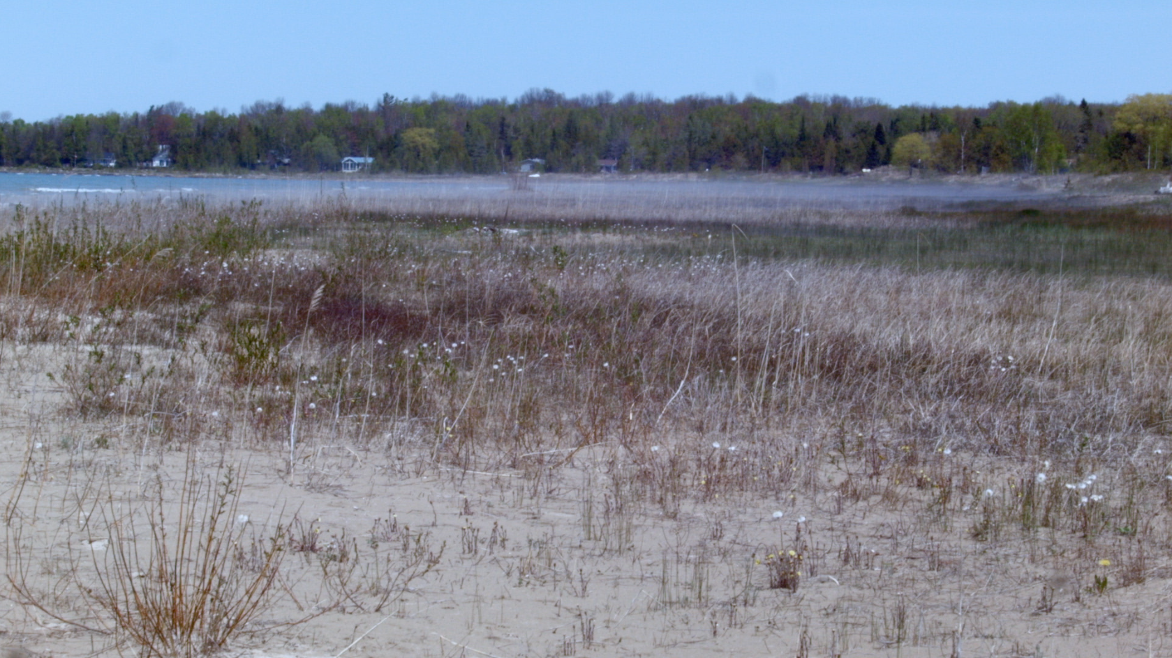

Figure 1: A still from Everything is awake! (2014)

To me, the shaking camera is both marker and producer of a kind of energy, an overflow of vibration and movement. Cinema is a machine that transforms and transfers energies (Stiegler 10), and the viewer is the performer of these energies, their active gaze amplifying or attenuating cinema’s unfolding vibrations. “All are priests both giving and receiving” (Brakhage 15). In *Everything is awake!*, the movement of the camera aims to further amplify and modulate the vibrational energy of its subject matter. The grasses and plants, as they move in the wind, are alive and awake energetically, and so too is the video apparatus they are captured by. All is in motion, textures for the eye, energy generated from their friction. The two-dimensional “significant” surface of the screen becomes variegated with texture, increasingly insignificant (Flusser 8). This is an active, haptic lensing that is “occupied by intensities, wind and noise, forces and tactile qualities” (Deleuze and Guattari 479). *Everything is Awake!* is concerned not with conventional spectacular or narrative intensities[15], but with awakening the bodily and energetic forces of haptic vision.

## The Technological Lens

Try an experiment for yourself: sit still and make a smooth pan across the room by turning your neck. It doesn’t work. The eye skips and jumps, refusing to be contained by the gesture. There is no natural pan, only jumps and stutters. Our very idea of cinematic vision is shaped by the steady, industrialized hand of Hollywood with its dollies and cranes and stabilizers, all of which are deployed in order to foreclose any disruption to the passive, frictionless, self-effacing flow of narrative. While cameras can smoothly track anything and even nothing, perhaps this only applies to us in certain situations or with certain subjects? [16] Instead, train your eyes on a moving object and follow it as it traverses your field of view. With something to track, the eye moves smoothly and without discontinuity, as if consciousness were somehow already cinematic[17] (Stiegler 13).

Another little perceptual experiment: wobble your head in your best imitation of a shaky, handheld telephoto lens. Despite best efforts, this doesn’t work either. The eye never shakes like a camera. In this case, rather than representing the translation of emotional worlds into direct visual form, or the pre-linguistic natural state of the eye (as Brakhage might argue), the shaking of the camera is always distinctly technological. It is constituted by, and only arises within, the camera’s specific optical techniques. Eyes do not tremble, except on the fringes of illness or psychedelic states. Camera shake is a leakage of the mechanism into the frame, a reminder that cinema is not really a window onto an unmediated, viscous reality. It is a confirmation that everything in cinema is constituted via the technology of the lens and the camera and the hand (and the screen, the viewer, the playback device, etc.). You are looking, but always within the framework of looking that cameras engender. “Every photograph is a realization of one of the possibilities contained within the program of the camera” (Flusser 26). Cinema is an interaction between our sight, the camera’s capacity for engendering new sights, and the hand that made the video.

The key here is to find strategies that allow us to think and see through these fixed distinctions between “natural” and “technological” ways of seeing. As Mark Hansen says in *Bodies in Code*, “technicity… as a relation to exteriority, as exteriorization, is not and cannot be something merely added on to some ‘natural’ core of embodied life. Rather, it must be understood to be a constitutive dimension of embodiment from the start” (ix-x). In other words, human perception and technology are co-implicated in our embodiment. They are not separate, nor is one a representation of the other. Lensing provides a set of strategies or modes of seeing that we can choose to deploy—and which are already deployed on us—as a means to negotiate amongst these distinctions of nature and technology, to see differently the way they influence each other.

**The Body Lens**

Ernie Gehr’s 1992 film, *Side/Walk/Shuttle*, performs a different kind of lensing. In it, Gehr films the San Francisco cityscape from the glass elevator of the Fairmont Hotel on Nob Hill. Over the course of forty-one minutes of screen time, Gehr ascends and descends in the elevator many times, shifting his camera’s orientation, composition, or tracking between each of the twenty-five takes (Sitney 214-15). Watching the film is meditative and oddly disorienting; one gradually loses the ability to precisely calibrate perspective and direction, and to disambiguate the motion of the camera from that of the elevator’s trajectory. P. Adams Sitney describes the experience of watching it like this:

“Divested of proprioceptive information about gravity and distance… Side/Walk/Shuttle’s cinematic subject must rely on the visual field for location and position… The top and bottom, and right and left, of the screen do not underwrite the corporeal coordinates of a viewer, who can nevertheless rapidly adjust to Gehr’s systematic disorientations. Sometimes the filmmaker composed his shots so inventively we momentarily lose track of the direction, but even when the direction is clear it is easy to get so caught up in the wonder of the film that one loses awareness of its horizontal and vertical reversals” (215).

Sitney’s use of the term “cinematic subject” here is notable. In film studies, it usually suggests a model of the viewer as constructed by the filmic apparatus, not simply as an autonomous observer[18]. Although *Side/Walk/Shuttle* is actively constructive, there seems to me to be a different alignment of subjectivity operating in the film. In a conventional Hollywood movie, subjectivity lies within the bounds of the screen, vested in the lives, actions, and perspectives of its characters. Our own subjectivity is woven into or subjugated to this narrative construction. For the duration of the film, we live our lives “*within* a life or the lives of people and events, real or fictive, to which we will have conjoined our time” (Stiegler 10). Without visible subjects or stories in *Side/Walk/Shuttle*, and more importantly, without a grounded representational perspective, we remain oddly centered within our own bodies and subjectivity. Yet, at the same time, our observational perspective is what enables us to be radically transformed by the disorienting operations and techniques of the camera. The film works itself into our perception of it, and its techniques produce something new *in* and *with* us (as we presumably do with it).

One could too easily read *Side/Walk/Shuttle* as simply a technical achievement, an exemplar of a structural cinema that makes us aware and attuned to the clarity of its formal elements, its shots, composition, and rhythms. For me, however, the film’s techniques and their unique transformational effects are not simply its subject, but rather form a kind of filmic material that couples unpredictably and non-schematically with the subjectivity of the viewer[19]. *Side/Walk/Shuttle* acts as a strange pharmaceutical, its carefully measured structure capable of potently altering our mental and physical states[20]. Scott MacDonald, explaining his visceral experience of the film’s effects to the filmmaker, said “I stood up when the film was over and actually found myself wondering if I should grab a chair: I had a momentary loss of what was up and what was down” (393). This is embodied lensing: we are proprioceptively transformed by the film, able to access a new perspectival space. The film has real and lasting effects on our minds and bodies, lensing our experience of gravity and visual perspective not in an imaginary, representational world limited to the screen, but here in this one, where quotidian experience can be imaginatively enriched, transformed, or afforded new possibilities by the embodied observer-film apparatus.

# Computational Materialism

In this section, I propose the concept of *computational materialism* and its relationship to open communities of practice. I explore how different strands of materialism operate and are systematized in my own digital cinema and music, situating my practice alongside the work of Amy Twigger Holroyd, Chris Welsby, and others. I use this idea of materialism to suggest an alternate perspective on digital technologies: one that emphasizes energy and signals over information and representation, ultimately suggesting that even computation has its own form of embodiment that can be experienced through technologically-mediated artworks.

## The Materials of Community

Every piece of “software art” in this project, along with the supporting technical frameworks and documentation, have been made using collaborative open community methods. Early ideas and concepts emerged via discussions with a distributed community of artists, designers, and programmers who have formed around the Fluid Infusion and Flocking communities[21]. In the case of Flocking, a community of perhaps one hundred people from around the world, mostly composers and sound artists, have used or contributed to it[22]. Even this text itself, from my first tentative notes and initial annotated bibliography through to the comments from reviewers of each section, was produced using open strategies[23].

Open software methods first emerged within the research software development culture of the 1970s at MIT, Berkeley, and elsewhere, and evolved into a more formalized body of practice in the late 1990s with the communities that formed to develop freely-distributed and openly-licensed software such as the Linux operating system and the Firefox web browser (Voyce 416) (Bretthauer 16). In *Wide Open: Open Source Methods and Their Future*, Mulgan, Steinberg, and Salem define open source software as “any computer software distributed under a license which allows users to change or share the software’s source code. Source code is the human-readable version of a computer program” (8). It is worth noting that, even within this simple description, the predominant emphasis by open source software developers and academics alike is placed directly on the source code as an originary and authorial text. Source code is cast as the “human readable” manifestation of software, in contrast to its runtime form. This framing raises questions, of course, about the ways in which software is readable and writable, when, and by whom. These questions will be taken up below, following a brief discussion of open source methods within my practice.

Mulgan, Steinberg, and Salem note that open source methods are “at the cusp of familiar tools,” often resembling conversations, formal research teams, academic scholarship, and DIY communities (15–6). Amongst the characteristics of open source methodologies described in *Wide Open*, several are particularly germane to my practice: transparency, peer review and feedback loops, and incrementalism (16). These strategies have helped to expand the networks of use and criticism for my work beyond my own local scholarly and creative communities. Work on Flocking, in particular, has been substantially supported by the very diverse perspectives that make up its community of users, contributors, and critics. By working transparently so that each change to the system (known as a “commit”) is visible to those following the project using the Github collaboration site[24], Flocking’s community is able to offer feedback, advice, and critical improvements while I work.

As an artist, however, working transparently and offering up a work-in-progress openly is a strange prospect, particularly when the project is still in the early stages of conception, before it has formed from a tangle of curious intensities into an object for use, discussion, or reception. Yet, as a result of my own openness and willingness to risk visibility in the tentative stages of creation, members of the community have been motivated to share their artistic projects reciprocally. I have benefitted from this mutual exchange significantly, not only gaining new design insights into how to support the needs and processes of artists who are significantly unlike me[25], but also learning new creative strategies by studying, experiencing, and working through the software art created by others in the community. For example, the approach I used while working with recorded sound in *Font Màgica* was substantially informed by my study of granular synthesis instruments created and shared by Alex Geddie, whose music for *Constructed Land* subtly lenses recordings of “classical” repertoire into new works that occupy a strange, buzzing, stuttering middle ground between quotation and transformation[26]. In the past, as an instrumental music composer, I was rarely able to have such ready access to the scores and recordings of “non-master” composers except those within my immediate (though nonetheless highly germane) sphere of artistic friendships within Toronto. To be clear, this is not an argument for global networks and against local ones; rather, it is an acknowledgement of the new forms of locality that can emerge “telesthetically” around the creative currents and capabilities of shared, networked artefacts and practices.

For me, then, the most essential characteristic of openness is not so much the availability of source code (although this is a prerequisite for other forms of openness), nor the enactment of a specific set of technical governance and legal policies, but the way that collaborative practices performed in the context of an inclusive community can engender artefacts that in some way materially embody these practices. Software that forms, to use McKenzie Wark’s term, new creative “*vectors* for a collective becoming” (*Hacker Manifesto* 159–60).

## Material Artefacts

As the term suggests, “open source” software development strategies, both socially and technically, emphasize source code as the locus of action and power within computation (Chun 21). Yet even the term itself–open source–is highly contested, particularly by those who identify instead with the “free software” movement. The distinction is marked by differences of legal position and political philosophy. “Free” requires, as an explicit feature of its license, that all modifications or derivations of the source code, including its combination with other works, must be distributed under the same terms as the original (Stallman et al. 32). This is “viral” licensing, where legal requirements spread to everything a piece of software touches. Sharing is legally mandated, never a spontaneous gift. Free software advocates promote this as a legal right to freedom–“free as in speech,” the ensconcement of a programmer’s right to express themself via source code, rather than the “free as in beer” of no-cost distribution (43).

While I admire aspects of Stallman’s project, I have nonetheless tried to intentionally avoid the use of the term “free” here in favour of “open.” Partly, this is to avoid what I see as the increasingly blunt ideological rhetoric and overt legalism of many “copyleft” free software advocates who gravitate towards software’s technical and logical construction (again, its source code), rather than its social and creative consequences–its *use in practice*. I prefer here to use the term “open community” instead of either “open source” or “free software.” This term aims at the possibility that “openness”—to creative expression and personal adaptation of software—might increasingly be conceived of as a characteristic of software artefacts themselves and the communities that form around and within them, not just of source code. In other words, software has the potential, if approached differently, to form a kind of *material* that can be worked on by means of itself, where the power to create and modify is available to all creators, not only computer programmers (Basman, *If What We Made Were Real*).

I argue that, as a result of this failure to confront the material possibilities of software, “free software” and “open source,” as methods and as political movements, remain largely technocratic constructions. Creative control remains centralized in software’s programming language source code, where only a limited community—those who have access to the specialized knowledge of computer programming—are able to benefit from its purported “liberty” and “freedom.” Via my software development practice, manifest here in Flocking, Aconite, *In Passing*, *Tofino*, and *Font Màgica*, I aim to extend the values and methods of open community practice into the material of software.

## Material Change

Wendy Chun describes the technical consequences of free software’s emphasis on source code as originary text:

“Richard Stallman, in his critique of nonfree software, has argued that an executable program ‘is a mysterious bunch of numbers. What it does is secret.’ Against this magical execution, source code supposedly provides an understanding and a freedom—the ability to map and know the workings of the machine, but, again, only through a magical erasure of the gap between source and execution, an erasure of execution itself” (Chun 51).

This Cartesian dualism that Chun refers to, source/execution, haunts computation to its core. It is implicated in a related binary that Chun overlooks, the separation of *code* from *data*. These dualisms crucially influence the way in which software’s form and potential is commonly understood today, and account for how its materiality is often overlooked or fails to actualize at all. Conventional source code, before it can be used, must be transformed into something different: a binary executable created by a *compiler[27]*. This transformation is unidirectional; as Chun suggests, it is an act of erasure that enacts the practical gap between source code, which is understood as fundamentally changeable and authorable—the “source” of creative power—and execution, which freezes the creative act and transforms it into an object and product. While code is apparently iterative and endlessly modifiable (by those with the skills and access, anyway), executables are not. One cannot unravel a piece of software and turn it into something else[28].

Software has no equivalent to Amy Twigger Holroyd’s *reknitting*, where existing knitted garments (most strikingly, even those that were mass-produced by machines) are modified or transformed in ways that were unanticipated by their original designers. Re-knitting, according to Twigger Holroyd, involves “a broad range of processes which can be carried out by individuals to alter existing items of knitwear. Re-knitting shifts a knitter’s practice from the creation of new items to the re-making of existing pieces” (“About Re-Knitting”). These processes include unravelling, cutting, grafting, insertions, stitch hacks, and replacements (Twigger Holroyd, “The Spectrum”). With these techniques, Twigger Holroyd and her friends make marvellously uncanny and expressive machine/hand hybrid garments by grafting new designs into old jumpers and socks.

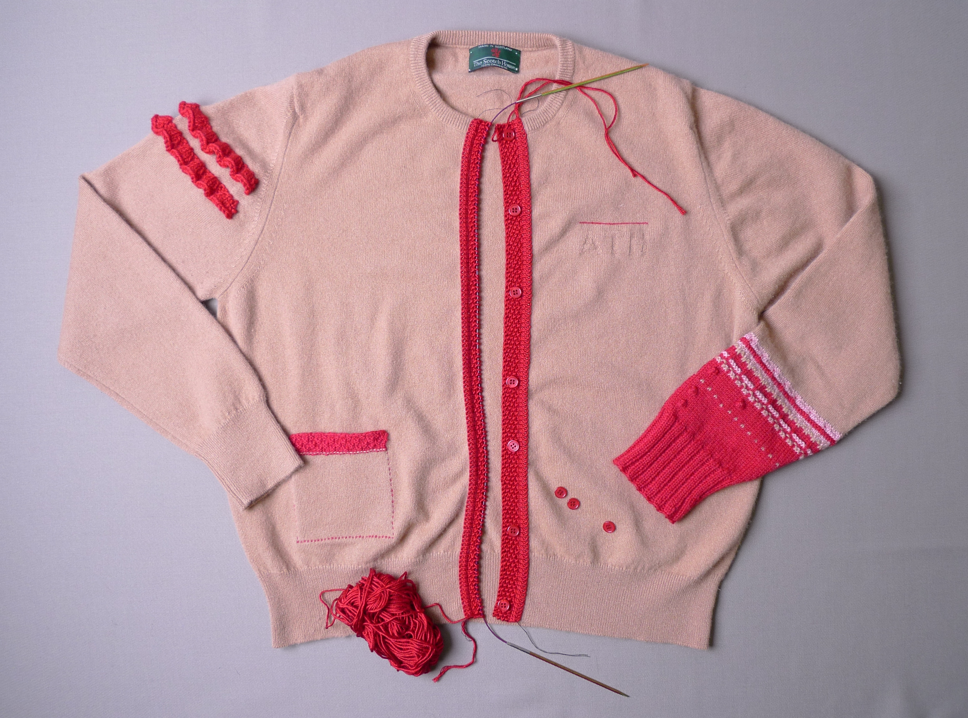

Figure 2: A reknitted cardigan by Amy Twigger Holroyd, which was created using a variety of slicing, unravelling, stitch-pickup, and grafting processes in order to modify an existing, machine-made garment with her own hand-made alterations. Image copyright 2013, Amy Twigger Holroyd. Reproduced with permission of the artist.

As an art form, re-knitting shows how new works can be created from old ones not just by reusing patterns or schematics, but also at the material level. Using Wark’s concept of a *vector*, which is a medium of production, communication, and becoming, a reknitted garment represents not only the *content* of the vector of knitting, but itself a new vector, or *form*, for the creation of another work from and within it. This newness is not just the result of a process of copying, quotation, or appropriation, but of the possibility of the artefact itself—its ability to engender new forms and futures, “the immaterial virtuality of the material” (Hacker Manifesto 100).

Yet it is also worth noting that re-knitting is not simply an idiosyncratic personal practice of Twigger Holroyd or her colleagues, but “an integral part of the practice of knitting” generally, a characteristic of the medium and the traditional methods of knitting itself (“About Re-Knitting”). Even when mass- and machine-produced, knitted objects retain their modifiability and, as a result, have the ability to support a “community of practice” within themselves. As artefacts, they can be worked on by multiple creators and can support unanticipated uses and after-the-fact adaptation. It is this ability to be serendipitously added to, subtracted from, grafted onto, or unravelled in a form not already planned for and designed into the object that defines my concept of *materiality*, the latent and unrealized potential of software. This materiality represents, I think, a form of *conviviality*, what Ivan Illich identified as the “autonomous and creative intercourse among persons, and the intercourse of persons with their environment [including tools]… individual freedom realized in personal interdependence” (*Tools of Conviviality*).

## Artifactual Materiality in Practice

I do not want to linger for long here on the technical details of Flocking, Aconite, or my software-based videos and compositions, since they are discussed extensively elsewhere[29]. However, I feel that it is necessary to briefly examine the mechanism by which these tools aspire to function as material vectors for further creative practices–my own and those of others.

By virtue of the manner in which they are constructed and the nature of the tools with which they are implicated, my software-based videos and music compositions were developed in a different way from most conventional software. Programming typically enacts a curious separation between code and data. Code represents the “logic” and “behaviour” of a piece of software. As Chun notes, source code is usually understood as the primary active agent of computation (19). In contrast, data is passive and raw; it serves as the material from which computational representations are formed. Programming languages are designed to process data, but are not themselves easily processable[30]. This means that ordinary programs are unable to understand or modify other programs[31]. Perhaps counter-intuitively, this oft-neglected computational self-referenceability, known as “homoiconicity”—the capacity for programs to treat themselves and other programs as data, and thus, to self-modify–is the prerequisite for individuals and communities (not just algorithms) to more directly participate in a convivial relationship with their software materials, bidirectionally as both users and creators (Basman, Clark, Lewis 255).

Programs made with Flocking and Aconite are data, not just code. This means, in particular, that they can be “understood” by programs and modified algorithmically as data, using the strategies that are typically used for other kinds of data processing. One particular technique is used extensively in Flocking programs to make them more amenable to material transformation: merging. In Flocking, instruments and signal processors are defined as “trees” of data that represent the connections amongst individual “unit generators,” or signal producing/modulating algorithms. Even the compositional or “meta-level” material of a piece can be defined as a tree of signals, as in *Font Màgica*[32]. By structuring a program as nested collections of named values, simple algorithms can be created (including the ones that are built directly into Flocking and its underlying support infrastructure) to “graft” or merge different signal trees together. A given instance of a signal tree created by one artist can be reconfigured without “forking” or changing the original source[33], nor requiring there even to be an intent or active design to support such adaptation. Where free software legally mandates sharing, code-as-data acts as an implicit, integral gift—each work holds the potential to serve as the material for new ones[34].

Like Amy Twigger-Holroyd’s spectrum of treatments for knitted objects[35], merging and other data processing strategies in Flocking provide a means to materially transform the nature and logic of a program, allowing its capacities and energies to be changed, re-channelled, or vectorized into new artistic forms. Notably, this “graftability” of my software can increasingly be applied at any point in the creative life of a program, from its inception as source code right up to the runtime manifestation of a program[36].

{

"buffer": "chopin-left", // Name of the buffer to play.

"speed": 1.0, // Regular playback speed.

"loop": 0.0, // Don’t loop playback.

"synthDef": {

"ugen": "flock.ugen.out", // Output unit generator.

"bus": 16, // Send to an interconnect bus.

"expand": 1,

"sources": {

"ugen": "flock.ugen.filter.biquad.lp",// Low pass filter

"freq": 1000, // Cutoff frequency of 1000 Hz

"source": {

"id": "volume-tracker", // Defines a named “landmark”

"ugen": "flock.ugen.amplitude", // An amplitude tracker

"source": {

"ugen": "flock.ugen.playBuffer", // A buffer player

"loop": "{that}.options.loop",

"speed": "{that}.options.speed",

"buffer": "{that}.options.buffer"

}

}

}

}

}

Figure 3: An example of how signal-processing programs are represented in Flocking. This program’s signal is used to determine the overall compositional structure of *Font Màgica.* It represents an instance of “declarative” data flow programming, where a collection of unit generators are specified within a loosely schematized data structure to: 1) read an audio file’s signal from a ‘bus’, 2) track the volume of the incoming audio, and 3) smooth the output of the amplitude tracker using a low-pass filter.

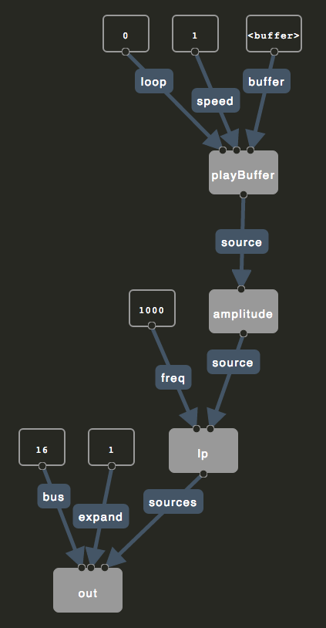

Figure 4: An illustration of the meta-level structure of Font Màgica, generated using Flocking's interactive textual/graphical programming environment (2016).

Additionally, Flocking and Aconite programs are constructed using a rich network of “landmarks,” or names, which provide stable references into every point of composition in a program. Traditionally, names in software are either inward-facing constructs or pseudo-legal contracts, designed to make it easier for a team of programmers to understand their code or to provide other programmers with a fixed repertoire of actions that can be performed with a piece of software. Computation fastidiously covers its tracks; composition too often simply erases its components. Without names and reference points into a composition of individual behaviours, a program is mostly invisible to the outside[37]. In contrast, works made with Flocking and Aconite bind each point of composition and behaviour to a name, a stable referent to which changes can be targeted, items can be removed, or new activities injected. Where ordinary function composition is smooth, leaving no traces, textures, or seams, my programs are woven with names; they provide the means to open the seams, unravel the material, and pick up the computational stitches to make something new.

## The Material Commons

So if the central quality of materiality here is the ability for something to be remade into something new without having been intended as such, what happens to the original? Channelling Heidegger for hiphop, Charles Mudede understands this transformation (something into its unintended) as arising from breakage, which brings to light the inner, unrecognized potential of an object. The broken object, now marvellously *enstranged*, has been knocked “out of the slumber of its primary function… it is now wide-awake, alert, alive” (“The Turntable”). To make its meta-music, the turntable must, in some way, fail to function as intended. Twigger Holroyd’s knitted transformations rely on a disconnection between forms—the transition from jumper to cardigan is more or less permanent, invariably involving some form of creative destruction to enact its renewal. But turntables and sweaters are objects with a very high degree of materiality, indeed. The digital is surely somehow different. Adapting Mudede’s poetics, my artistic software aims at becoming hypnagogic media: alive at the threshold between sleep and consciousness, able to move in either direction, to wake up into something new or fall back into the same dream without shattering in transition[38]. Connected. Right now, my own pieces are slumbering on Github[39], waiting to be awoken as the vector for a new work of art by me or someone else.

Whatever happens to the turntable and the analogue vinyl record, James Brown, after all, is never broken by a digital sampler’s manipulation of him, nor is his (or the sampler’s) essence somehow lost or activated by the process. Transformation is general and ubiquitous when it is digital. Although it may seem that it is digital media’s reproducibility that affords such zero cost transformation without breakage, reproducibility, in itself, is another form of breakdown. Every software programmer knows the impossible tangle of duplication that is the result of the copy/paste procedure. So perhaps it is not the digital’s infinite reproducibility that allows it to avoid destruction in the act of recreation, but its capture within a logic of signals and loops: the repetition, modulation, and filtration of materials into something new. “It is this act, replaying, that marks the real rupture in the mode or method of production” (Mudede).

Echoing this idea of “replaying” and drawing it back to the theme of community, Stephen Voyce imagines a more general mode of what he calls “open source poetics,” which is defined by “a decentralized and nonproprietary model of shared cultural codes, networks of dissemination, and collaborative authorship” (407). His view of open communities and their relation to art practice focuses on appropriative, readymade, remix, and “uncreative” strategies, which call into question the role of singular authorship and shift creative emphasis instead towards how poetry contributes to a “poetic commons” of textual references and transformations (408). While, as discussed above, I think it is a mistake to focus only on the citational or appropriative modes of open communities, I nonetheless want to explore Voyce’s idea of a commons in which works of art serve, via quotation and systematic transformation, as the “raw materials,” or signals, for new works.

Notably, Voyce argues that, underneath the agonistic and oppositional tropes of modernism, open community tactics have been an ongoing feature of avant-garde art movements such as Dada and Fluxus. For Voyce, this method of inter-authorial materiality suggests that avant-garde artists have an ongoing role and responsibility “to create and fortify public domains of open source knowledge, to challenge excessive restrictions placed on language and information, to bring forth marginalized knowledges from a position of inaccessibility to the public at large, and to produce and share artistic tactics and works that challenge intellectual property. That which is at stake is nothing less than open accessibility to culture” (427–8).

## Material Systems: Font Màgica, Chris Welsby, and Tofino

In my own work, both concepts of the commons—artefactual software materiality and the appropriation and transformation of concrete material—play a role alongside each other. In this section, I will describe how quotation and appropriation functions in *Font Màgica*, and then, via the work of Chris Welsby, extend this thinking into the role of systems, signals, and algorithms in both *Font Màgica* and *Tofino*.

### Font Màgica

For my soundtrack to Izabella Pruska-Oldenhof’s film *Font Màgica*, at her request, I used a recording of Chopin’s Prelude No. 15 (“Raindrop”) as source material, layering and blending it with the sound of radio astronomy events. Since Pruska-Oldenhof had initially edited the film to the Chopin piece, I wanted to retain some of the affective logic of Rudolf Serkin’s expressive piano performance in my treatment of it. Using a network of amplitude trackers and granular signal processors, the piece’s formal structure, its dynamic phrasing, was used as a signal with which to modulate and filter the playback of multiple layers of the Chopin along with the astronomical sounds. The Raindrop prelude’s own compositional structure was fed back into the system, refracting itself into multiple layers of sound that are eerily offset from and mis-registered to the original, but which nonetheless carry a strangely warped expressivity. Like Pruska-Oldenhof’s visuals, it is an overtly refractive piece, full of prismatic colours, distorted ghost images, and passing fragments of a receding original.

Neither a work *of* traditionally-constructed originality nor one *about* appropriation, Font *Màgica* is a lensing apparatus, a technical-sonic system that is *complicit with* Chopin and solar flares and the film’s visuals and my signal processing algorithms. Though slightly different each time due to random signal changes, *Font Màgica* is not an “open” work so much as an obsessed one. It is obsessed with its own material closing in on itself via signal processing. Chopin’s *Raindrop* appears everywhere, replicated at all levels as both a structuring force as well as a microsonic substrate. *Font Màgica* aims for a form of systemic closure and inner self-similarity; a closure that paradoxically “realizes openness in its radical sense: not as openness toward the possibility of contingencies from the outside, but as a ‘being opened’ by the contingent materials that form the work” (Negarestani 3).

Algorithms paint an artwork into a corner. They limit possibilities rather than opening a work up to them. A “rigorous and twisted mode of closure,” algorithms allow a work to close in on itself and its materials (2). Too often algorithmic art is couched in a rhetoric of power and control that demands a distinctly perspectival position, like the abstract, theoretical, architectural view from above in De Certeau’s reading of the city from the top floor a skyscraper (92–3). For me, algorithms are not about the control afforded by such an over-arching perspective on a system, nor are they a Cageian opening up of the work to the contingencies of a constructed “nature” distinct from the techniques used to register it[40]. I use algorithms in my work specifically in order to have my view of the aesthetic terrain partially obscured, to find localized energies that emerge not from the abstract adherence to rules, nor openness to chance, but from a kind of obsessive practice that allows a creative system to start feeding on itself, to “uncover itself as the field of experimentation of its contingent materials as a conspiracy plotted by anonymous materials” (Negarestani 4).

### Chris Welsby’s Colour Separation

*Font Màgica*’s soundtrack, though perhaps obliquely, invokes for me the work of Chris Welsby, whose films form “cinema systems” that bind together, both as material and method, the technology of the camera and the energies of the natural environment. In Welsby’s films, the wind, waves, sun, rain, and clouds all are allowed to imprint themselves onto the chemical, mechanical, optical, and durational surfaces of his cinema. “Mind, technology and nature are not experienced as separate things divided along Cartesian lines but as interconnected parts of one larger, dynamic system” (Welsby, “Technology, Nature, and Software” 102). Nature and technology are not opposites; they form an ecology of interactions, materials, and influences.

For his 1974 film, *Colour Separation*, Welsby ran “film stock three times through a stationary camera; once for each of the light primaries. In the composite image, anything moving is represented in primary or secondary colour whilst anything still, having been filmed through all three filters, is represented in ‘correct’ colour” (Welsby, “Film notes for Colour Separation”). The effect is, of course, literally prismatic: the film’s view of a harbour with boats floating at their mooring is refracted and multiplied into coloured layers by natural influences and the passing of time. Everything is gently in motion; boats and waves split and merge as colourful, offset ghosts that double and triple each other while they bob about in the wind and tide over the course of the film. While *Colour Separation* could be read, once again, as simply an instance of a structuralist demystification of film, allowing us to see the way in which a colour image is produced within the camera, I think it is more productively understood (additionally) as mild form of psychedelic lensing: it offers up a glimpse of time as it is vibrantly transformed into hue. Welsby’s network of emulsion, filters, camera, and weather gloriously intensifies our perception of time, folding it into the space of the camera frame and indexing its passing with colour. *Font Màgica*, I hope, analogously deploys its systemic transformations to bring out the in-between moments, the ghosts and stutters of Serkin’s piano playing, multiplying it into layers of shifting sound colour.

### Tofino

*Tofino* takes up Welsby’s spatialization of time and his wind-camera coupling to create a somewhat different kind of system. It consists of a series of long takes of breaking surf captured at Wikaninnish Beach near Tofino, British Columbia. The first part of the video is structured as a “temporal panorama”: each static shot moves the camera a frame or so to the right, cumulatively representing a 180° view of the beach[41]. Space, in a sense, is temporalized by the way the shots are sequenced. Time, too, is spatialized in *Tofino*. Two versions of each shot are composited or layered together: one layer runs at the standard 24 frames per second (cinema’s “real” time), while the other layer gently speeds up and slows down in an oscillating rhythm. A simple Flocking signal generator, which outputs a slowly-modulated triangle wave, is connected to the playback rate of the latter video layer, causing it to move faster and slower in a motion that echoes the swell and break of the waves on the beach. Composited together, we see the two timelines moving in and out of phase. When the modulated layer runs more slowly than real-time, we see breaking waves echoed moments later by their composited ghosts. When it moves faster, actions are anticipated ahead of “real” time: we see a future. This technical-elemental coupling uniquely makes visible, in a way that might not be possible without such a video apparatus, the otherwise invisible mutability and bidirectional flux of time. Or perhaps this system actually brings into being—makes real—a new kind of time via its mediations and modulations?

The effect can be disorienting. As a result of *Tofino*’s temporal phasing, cuts occur at different times in one layer than in the other, causing a new shot to be dizzyingly overlaid on top of the previous one for a period. Throughout, the camera is resting directly on a wooden ledge and is frequently buffeted the strong winds, causing it to shake and shift its position. At these moments, the layers are further deregistered, emphasizing the phasing and doubling effects and evoking a disorienting “double vision” effect that hints at the proprioceptive ambiguity of Ernie Gehr’s Side/Walk/Shuttle discussed earlier.

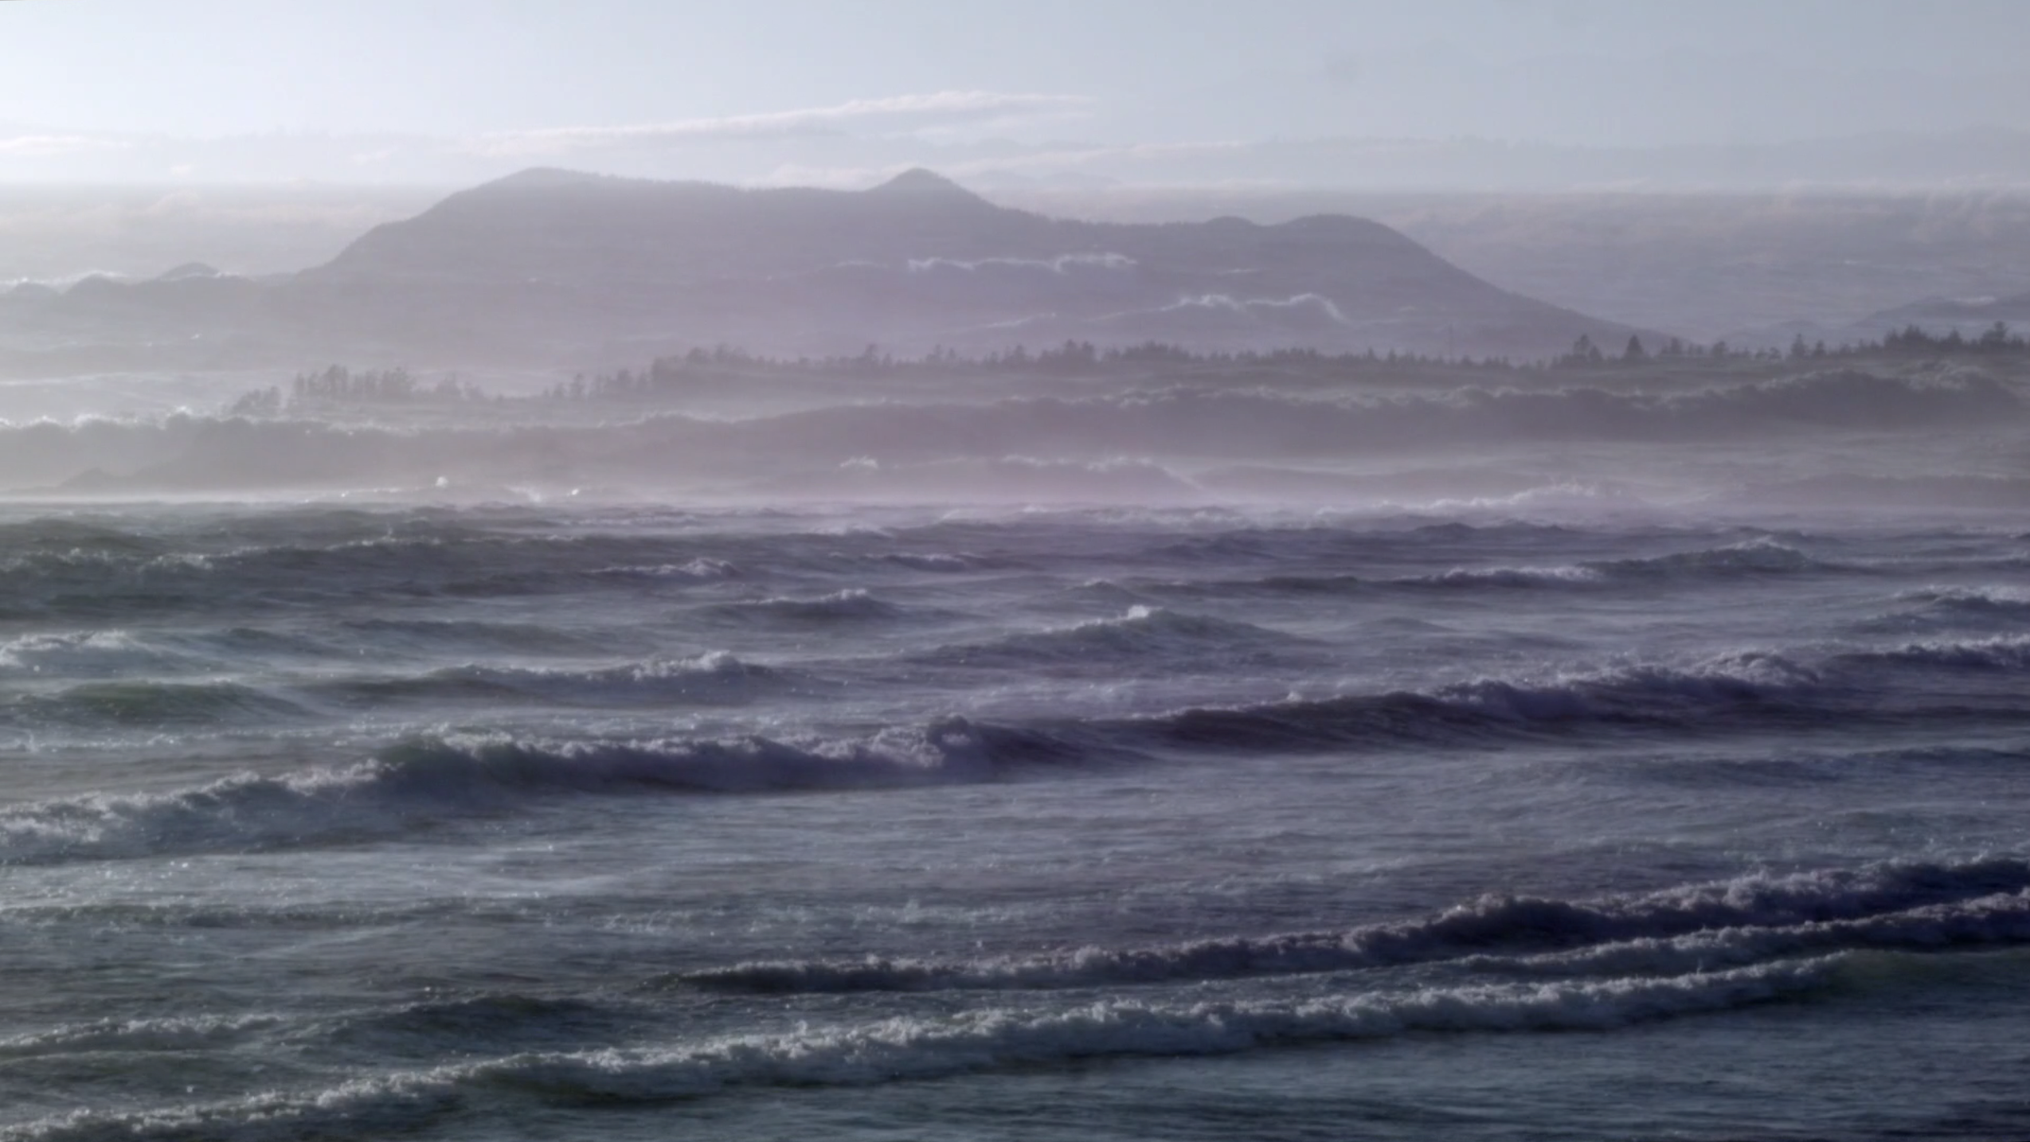

Figure 5: A video still from *Tofino* (2016).

Jean Epstein, writing in 1946, imagined that the cinema’s mechanical-perceptual apparatus, with its strange capacity to materialize time, represented a new form thinking: “This machine that stretches or condenses duration, demonstrating the variable nature of time, preaching the relativity of all measures… Without it, we would see nothing of what time might feel like materially… [it is] a form of thinking by the rules of analysis and synthesis that, without the cinematographic apparatus, humans would have been incapable of implementing” (18). Epstein’s “intelligence of the machine” envisions cinema as a transformational technics that couples with human perception. As Bernard Stiegler later describes it, “cinema weaves itself into our time; it becomes the temporal fabric of… unconscious consciousness” (11). Here, however, the nature of the system and its slow and methodical unfolding suggest a model of cinematic time that is not just coextensive with our own time, but actively modulatory of it; the temporal fabric of a “conscious consciousness” of active and self-aware viewing.[42]

## In Passing: Energy, Duration, and Embodiment

Computation is prevailingly understood within a framework of informatics and immateriality, rather than one of energy and embodiment. Yet, I argue, the digital also provides an opportunity to activate our embodiment and transform our perceptual energies, sense of time, and awareness of our physicality in a manner that extends well beyond the screen and loudspeaker.

*In Passing* (2015) is an eighteen-minute video consisting of three close-up shots of a dried-out leaf on the floor of my apartment. It is the kind of scene that would have been easy to miss: an old leaf had blown into the house on a windy summer day and became tangled in cobwebs in the corner, flickering aimlessly with the breeze. There is nothing particularly profound about the scene, no narrative or metaphorical schema motivating its capture on video. It was simply there, nearly but not quite lost amidst the quotidian activities and distractions of life at home.

Up close, the texture of the leaf is particularly visible—its ridges and curls, growths and cracks. Behind it, the linoleum tile floor is also thick with texture and grit. Over the course of the first shot, which is the longest of the three, the leaf’s texture is amplified and granulated by digital processing. Eventually, it becomes apparent that the leaf is gradually disappearing, the algorithmic process eroding it away to reveal the floor beneath it. Leaf and linoleum, figure and ground, flatten and merge. The leaf eventually blows across the floor to the other side of the frame. Just before its outline fades from view completely, it is swept out of the frame by a sudden gust of wind. After several moments spent in its absence, there is a cut. The leaf returns, seen from another angle. We hear a crackling sound, analogous in quality and rhythm to the leaf’s granulation in the previous scene. In this case, though, the digital intervention (the sound) is additive, rather than subtractive. The leaf remains intact. In the final scene, the leaf is once again seen from a different angle. Silent once more, the visual erosion has returned. This time it is apparent that the digital processing is eating away at the entire scene, not only the leaf. More quickly than before, the leaf again fades to nearly nothing and then is caught by the wind and blown out of the frame. The video ends.

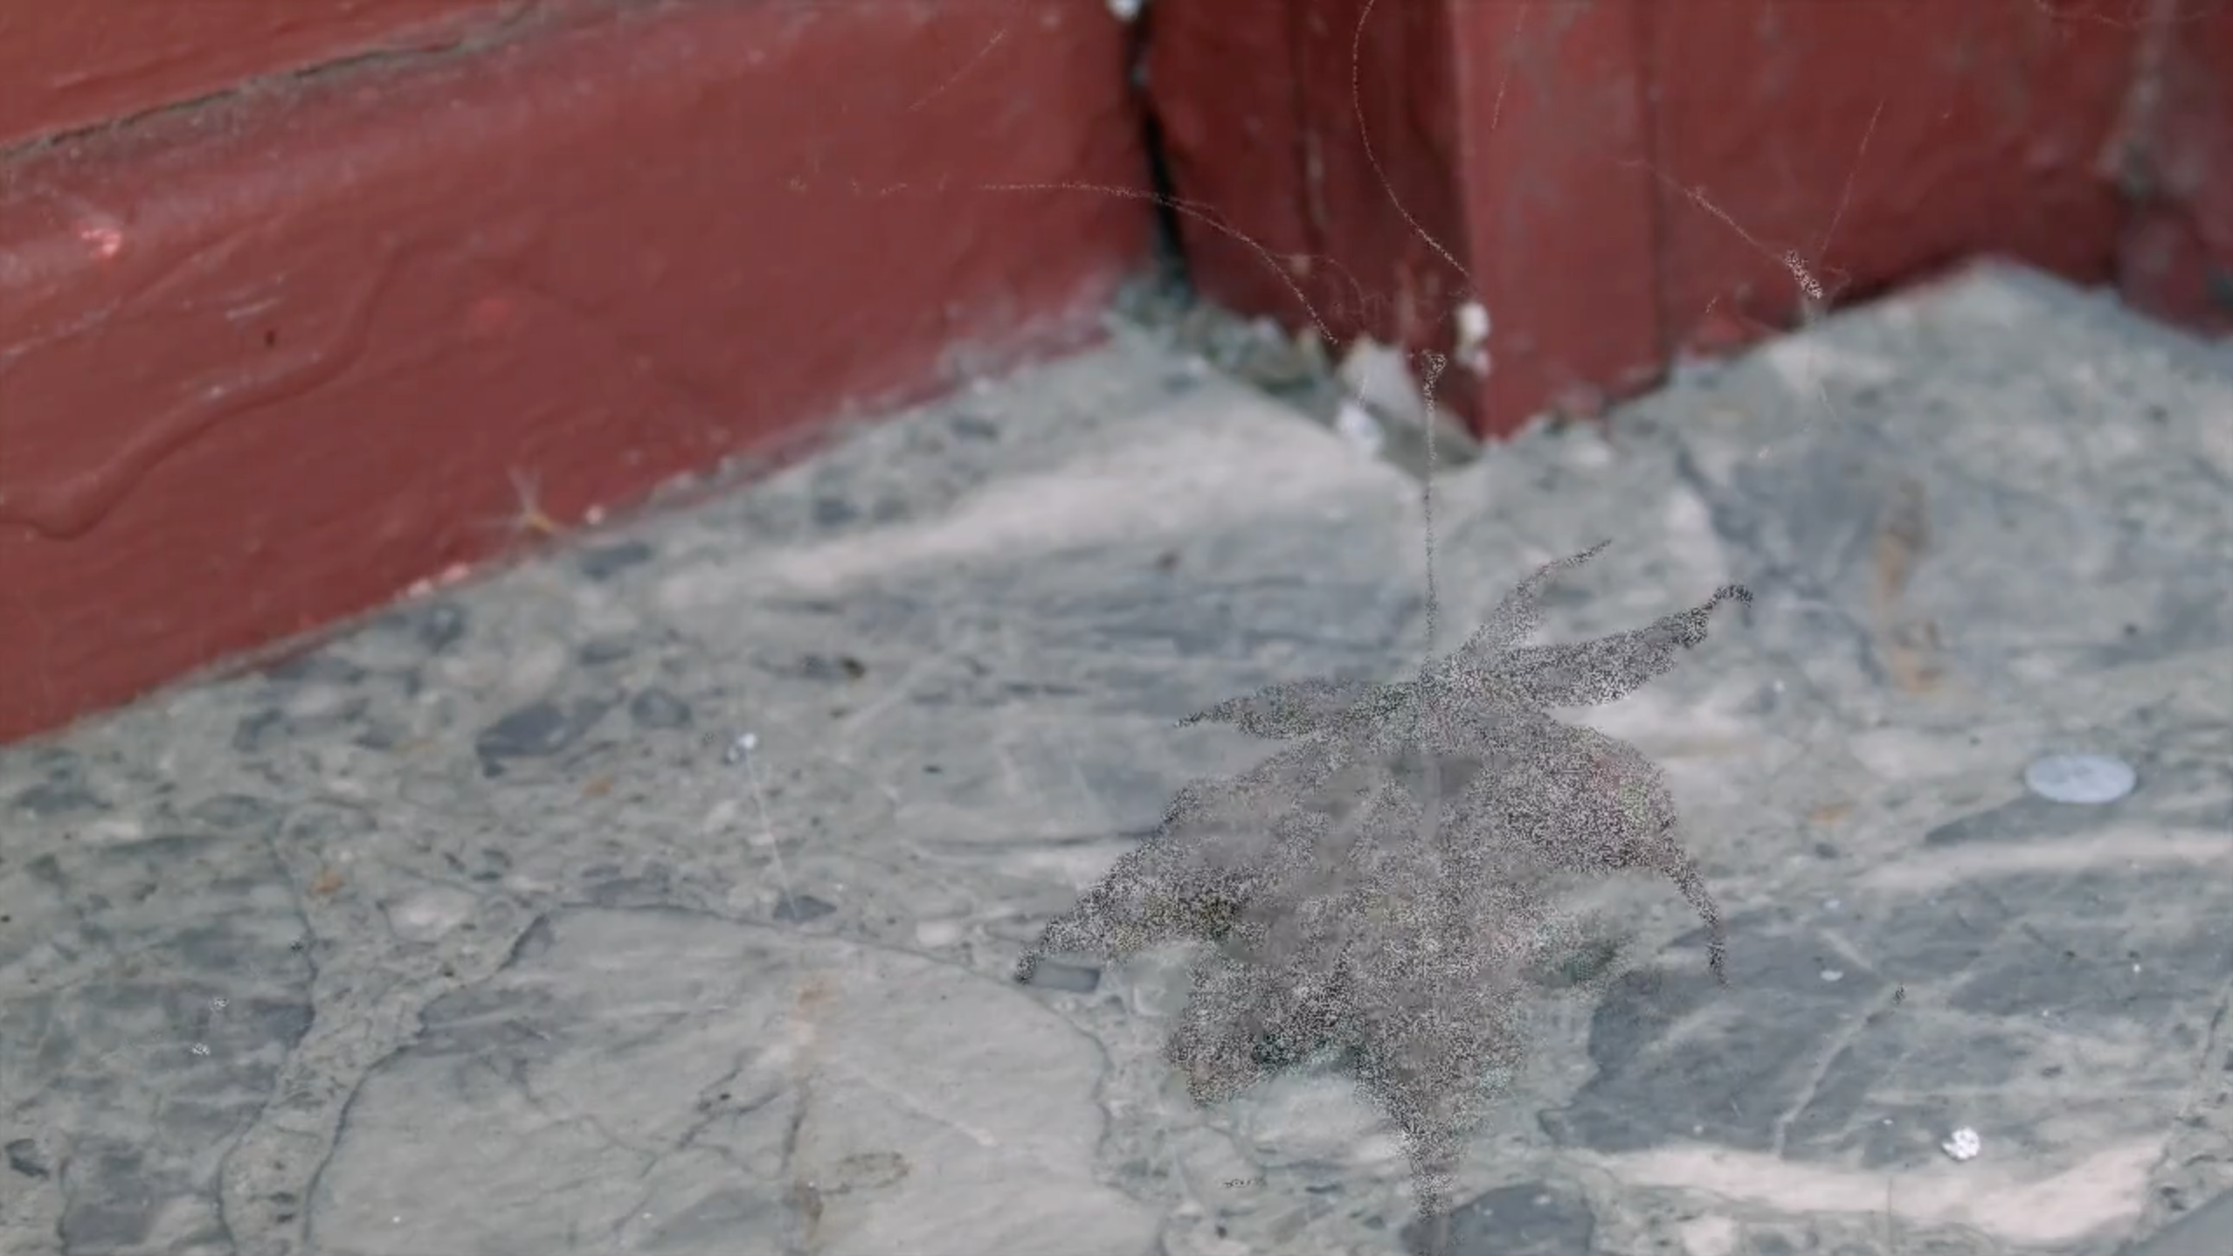

Figure 6: A video still from *In Passing* (2015).

This description of *In Passing* highlights several aspects that are relevant to a discussion of its particular embodied technics. First, it is a slow and arguably repetitive video. There is no story to escape into, no self-effacing narrative or expressionistic flow. It takes time and demands attention. This time is systemic in nature: *In Passing*’slength, tempo, and repetitions simultaneously form its own temporality and are coupled with the “uneven medium” of the viewer’s sense of time[43]. Secondly, the video draws together several forces: the natural energy of the wind and the leaf’s hapticity on one hand, and the technological mediation of the camera’s framing and editing along with the modulatory capacity of the digital signal processing algorithm on the other. Once coupled to the embodied perception of the viewer, *In Passing* forms, yet again, a kind of system in which natural, technical, and bodily energies co-mingle over time. It is an aggregator and modulator of these forces. In this system, the camera serves as a means to amplify the small energies of everyday life, while the processing shifts and expands them. The viewer activates the system, transforming these energies with their eyes, ears, and bodies.

Much like Jack Chambers’ concept of perceptual realism, *In Passing* suggests that a work of art can function as a system to see (and hear) with, a means to generate and transform experience.

“Perceptual realism incorporates two systems of technology (historic and industrial) and two systems of visibility (body and mind) to structure a reflector-object of experience… two inter-working processes motivate and advance one another intentionally to create this transmitter unit… The closure of these two extending systems… creates its own object. It is an object to see with, rather than a thing just to see” (Chambers 41–2).

While Chambers uses the term “object” here, he is nonetheless suggesting that the work of art can serve as catalyst for an ongoing process of perceptual transformation within everyday experience. In a suitably dark room and with sufficient attention, the continuously shifting, stochastic sparkles of *In Passing*’s digital processing have a way of entering into a viewer’s persistent vision, activating a mode of seeing that continues beyond the video’s duration. Sparkles can be seen (and imagined) in anything, even with eyes closed. This model shifts the art, by means of an engaged and embodied viewer, beyond the temporal and spatial frame of the video and out into the world. *In Passing* thus becomes implicated with our own seeing and hearing, a sort of perceptual synthesizer (perhaps this what Chambers means by a “transmitter unit?”) that modulates the carrier wave of perception with the work’s own oscillations. A system of creative, reciprocal, and active seeing that continues to operate in the world. “My eye… being instrument for striking sparks, is bequeathed visions at every illumination… Similar vistas being available to any viewer willing to release his eye for comparable movement” (Brakhage 26).

*In Passing*’s processes—its “system to see with”—make a material imprint on a sensitive viewer’s perception over time. Its duration, coupled to its highly reduced visual vocabulary, slow pace, absence of narrative, and preponderance of silence, has the tendency to mark or make prominent our embodiment. “The still body is still a body doing. It is acting and being acted on… the activity of stilling can be considered a choreography of non-acts or counter-movements to the host of budding impulses that develop into drives and ultimately forms of action” (Priest, “Felt as Thought” 47). Even as seated and relatively still cinemagoers, we notice our bodies, and this awareness of ourselves (and of others in the cinema) modulates the passing of time in unpredictable ways.

With the absence of sound and story, the experience of time in *In Passing* is concentrated into a curious form of waiting. It suggests an affective modality of time that, as Howard Schweizer describes it, “must be endured rather than mastered, felt rather than thought” (23). Our usual conception of waiting is, of course, highly bound up with associations of discomfort, frustration, lack of attention, and of temporariness–a passing through rather than lingering. But while waiting certainly fails, it does so radically. It fails to achieve, to direct, to participate in the capitalistic drive of accomplishment, success, and productivity (8). It opens time up. This form of waiting foregrounds our bodies, allows us to experience duration creatively and aimlessly, rather than instrumentally. It is not about “how we pass through waiting, but how we are in it… the quality of waiting as such” (11). *In Passing*, like *Tofino*, manipulates its temporality, transforming this particular moment in time by stretching it and folding it onto itself in layers; the leaf’s presence and absence occurs simultaneously. We experience time’s transience and can occupy its passing, carrying something of it away with us. Yet this waiting is also a reminder of our own passing. Our time is coextensive with that of the leaf: “the body that endures… is always also a reminder of its mortality” (Schweizer 17).

This ambivalence of waiting, of time alternatingly passing by in distraction and thickening with attention, forces us to contend with our bodies in the present moment, whether shifting in our seats or hearing our own breathing. Boring or not, we are in it, and aware of it; and aware, too, of this awareness and its weird affective energy. “The boredom of waiting does not describe but instead witnesses its happening. It, and those who wait, become, in Lyotard’s lovely words, ‘good intensity-conducting bodies,’ bodies whose alternating expressions of wonder and fatigue are testament to the radical ambi-valence of events” (Priest, *Boring Formless Nonsense* 73–4).

While *In Passing*’s “system to see with” is outwardly transformational, capable of changing and undoing a viewer’s sense of time and perceptual energies, it also operates its own internal mode of transformation at a technical level. The image processing algorithm that causes the leaf to slowly erode is driven by two time-varying values: the threshold, which specifies the degree to which the leaf should be consumed by its background, and the noise seed, a value that influences the random sparkle pattern and its rate of change. These parameters are generated by a digital synthesizer, a software component ordinarily intended to generate sounds, which has been repurposed to modulate the parameters of the visual transformation of the leaf. In the second section of *In Passing*, the crackling sound is produced by connecting this synthesizer directly to the speakers instead of to the visual effect. Here, the synthesizer acts as a flexible “translation mediator,” to use Don Ihde’s terminology (112), mapping the sonic to the visual and back again.

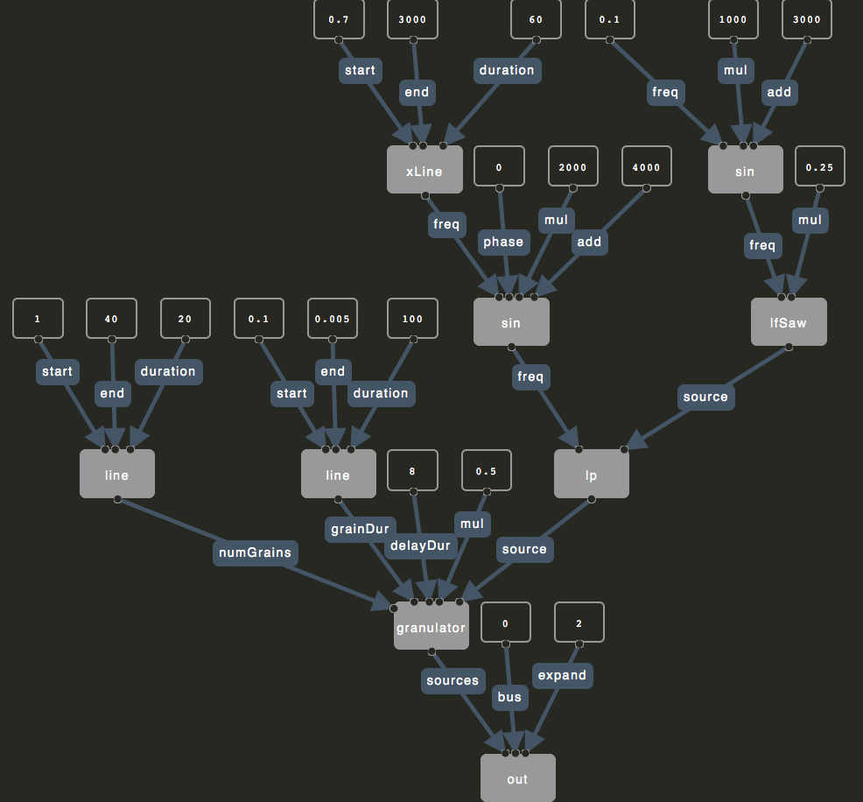

Figure 7: Diagram illustrating the signal path of oscillators and modulations comprising *In Passing*’s synthesis algorithm (2015).

Yet there is something troubling to me about Ihde’s idea of translation, at least when thinking about how *In Passing* operates. The idea of translation is predicated upon an informational model of the digital (an admittedly very dominant model at the heart of the system, as illustrated by the definitional term “information technology”), rather than one of the energetics, signals, and flows described earlier. Ihde’s translational mediation is based on an abstraction of data from its representation. “To become available the information, data, or image must be transformed, translated, into what is open to our anthropological constant, an embodied human” (113). The power of Ihde’s model is that it positions embodiment centrally within the realm of the digital, but it also carries with it a sedimented transmission model of communication, positioning data “above” representation as a (relatively) stable referent or message preserved within a linguistic system of translation.

One could mistakenly read *In Passing*’s repurposable synthesizer algorithm as proof of data’s translatability across representations—we successfully both see and hear its influence. However, within this hearing and seeing, it becomes clear that the nature and effects of this algorithm are fundamentally changed and refigured by its medial transformation. Bruno Latour offers a conceptual alternative to translation, one that rejects the idea of data as raw material. He argues that there is no such thing as information, “there is only transformation. Information as something which will be carried through space and time, without deformation, is a complete myth” (Lovink and Shultz). Instead, he proposes a model in which representations participate in an aligned network of transformations—“immutable mobiles” that represent the “constants carried intact through the transformation of the media” (Latour 425). Data is no longer static, objective, and at a distance from representation (or perhaps more accurately, no longer even distinguishable from it), yet meaning can still emerge from the alignment of constants across a series of transformations. “What is kept constant from one representation to the next is morphed, quite naturally, into the thing itself” (427). However, the challenge of Latour’s model is that it is profoundly difficult, in practice, to identify and register these constants across transformations. This is, in part, the creative gambit of *In Passing*, the activity embedded in its perception—to integrate, extend, and intensify this network of transformations. *In Passing*’s immutable mobiles, left open for viewer engagement, are the pulsations and vibrations of its various energies—its rhythm, pacing, and durational unfolding—while its algorithms act as modulators of this energy as it is passed back and forth between visual and sonic mediators. Here, there is no information, only energy, duration, and embodiment.

# Conclusion

"I find myself living in a world populated by materially diverse, lively bodies. In this materialism, things—what is special about them given their sensuous specificity, their particular material configuration, and their distinctive, idiosyncratic history—matter a lot... Earthly bodies, of various but always finite durations, affect and are affected by one another. And *they form noisy systems or temporary working assemblages* that are, as much as any individuated thing, loci of effectivity and allure. These (sometimes stubborn and voracious but never closed or sovereign) systems enact real change" (Bennett 233).

By positioning my approach to cinema and software within a framework of materiality and embodiment, I aim to suggest that these apparently “immaterial” forces actually possess real bodies. Digital bodies, like others in the world, can effect and can be effected by viewers, technologies, environments, and the cinematic apparatus as whole. Rather than emphasizing the representational or informational qualities of cinema and computation, I am interested in a distinctly less abstract approach, or perhaps more accurately, one in which abstractions have the capacity to “release the potential in the material world,” to create new forms and vectors of creative expression (Wark, *Hacker Manifesto* 18).

My concepts of lensing and computational materiality suggest that individuals and communities can weave new experiences and artefacts from the materials of existing work. Moving forward, I will continue to extend Flocking and Aconite’s capacity to support unexpected and serendipitous practices within my own work and that of the larger creative community surrounding these tools. Indeed, a major future activity suggested by *Insignificant Surfaces* is to extend Flocking and Aconite to support live video processing and transformation, in which I can play the roles of both “original creator” and “re-knitter” within a performance scenario by modifying and extending processing networks in real-time. In many ways, *Insignificant Surfaces* represents a snapshot in time of an ongoing, accumulating body of videos and creative technologies.

Within the context of this project, I have attempted to rethink digital creativity and interdisciplinary practice using the methodologies and concepts of adjacency, lensing, and computational materiality. I have argued for a renewed focus on the open and collaborative possibilities of software development, and have attempted to draw out an alternative economics of software based on integral sharing and exchange of material artefacts. I have argued for the powerful and complex embodied effects of cinematic systems in the work of Chris Welsby, Ernie Gehr, and others, and have offered up my own videos as further possibilities for lensing and transforming our perception of quotidian experience.

The lenses and materials presented in *Insignificant Surfaces,* both theoretical and artistic, are not offered as definitive or universal models. Instead, they are starting points and speculative strategies for discovering new forms of vibrant digital bodies and their systemic relations to a variety of creative and technical apparatuses. To this end, I hope that this project provides the tools and materials with which others can find and discover their own diverse and idiosyncratic lensing strategies, artworks, and software projects.

# Works Cited

Agamben, Giorgio. *What is an Apparatus?*. Trans. David Kishik and Stefan Pedatella. Stanford: Stanford University Press, 2009. Print.

Arnold, Martin. *Observations About, Around and Beside Burrow Out; Burrow In; Burrow Music.* Diss. University of Victoria, 1995. UVicSpace, Web. 20 Mar. 2016. https://dspace.library.uvic.ca/handle/1828/6385

Arnold, Martin. “Rat-drifting.” Program notes. *Something New, Something Old, Something Else*. City Hall, Sheffield. 6 May 2009. Web. http://eprints.hud.ac.uk/5697/2/Trunk_SNSOSE_prognotes.pdf

Bal, Mieke. *Travelling Concepts in the Humanities: A Rough Guide*. Toronto: University of Toronto Press, 2002. Print.

Barad, Karen. “Posthumanist Performativity: Toward an Understanding of How Matter Comes to Matter.” *Signs: Journal of Women in Culture and Society* 28.3: 801–831. Print.

Barry, Andrew, and Georgina Born. “Introduction.” *Interdisciplinarity: Reconfigurations of the Cocial and Natural Sciences*. Eds. Andrew Barry and Georgina Born. London: Routledge, 2013. Print.

Basman, Antranig. “If What We Made Were Real.” *Fluid Project Wiki*. 2 May 2014. Web. 11 August 2014.

Basman, Antranig, Colin Clark, and Clayton Lewis. “Harmonious Authorship from Different Representations.” *Psychology of Programming Interest Group Annual Conference 2015*. Melanie Coles and Gail Ollis, eds. Web. http://www.ppig.org/sites/default/files/2015-PPIG–26th-Basman.pdf

Basman, Antranig, Clayton Lewis, and Colin Clark. “To Inclusive Design Through Contextually Extended IoC: Infusion IoC, a JavaScript Library and Mentality for Scalable Development of Accessible and Maintainable Systems.” *Proceedings of the ACM International Conference Companion on Object Oriented Programming Systems Languages and Applications Companion* (2011): 237–256. Print.

Bennett, Jane. “Systems and Things.” *The Nonhuman Turn*. Ed. Richard Grusin. Minneapolis: University of Minnesota Press, 2015. 223-235. Print.

Brakhage, Stan. *Essential Brakhage*. New York: McPherson, 2001. 25­–36. Print.

Bretthauer, David. “Open Source Software: A History.” *UConn Libraries Published Works* 7 (2001). Web. http://digitalcommons.uconn.edu/cgi/viewcontent.cgi?article=1009&context=libr_pubs

Bryant, Levi. *The Democracy of Objects.* Michigan: Open Humanities Press, 2011. Web. http://quod.lib.umich.edu/o/ohp/9750134.0001.001

Cage, John. *Silence*. Middletown: Wesleyan University Press, 1961. Print.

Cecchetto, David. “Thoughts on Creative Practice and Research.” *The Occulture*. 10 Feb. 2013. Web. 26 Jan. 2016. http://www.theocculture.net/thoughts-on-creative-practice-and-research/

Cecchetto, David. “vagrant(ana)music: Three (four) Plateaus of a Contingent Music.” *Radical Musicology* 2 (2007). Web. http://www.radical-musicology.org.uk/2007/Cecchetto.htm

Chambers, Jack. “Perceptual Realism.” *Films of Jack Chambers*. Kathryn Elder, ed. Toronto: Toronto International Film Festival, 2002. 33–44. Print.

Chiles, Webb. *A Single Wave: Stories of Storm and Survival*. Dobbs Ferry: Sheridan House, 1999. Print.

Chun, Wendy. *Programmed Visions: Software and Memory.* Cambridge: The MIT Press, 2013. Print.

Clark, Colin and Adam Tindale. “Flocking: A Framework for Declarative Music-Making on the Web.” *Proceedings of the International Computer Music Conference, International Computer Music Association* (2014): 1550–1557. Web. http://www.smc-conference.net/smc-icmc–2014/images/proceedings/OS13-B11-Flocking.pdf

Clark, Colin, Dana Ayotte, and Antranig Basman. “About Us, With Us: The Fluid Project’s Inclusive Design Tools.” *Proceedings of the 2016 Human Computer International Conference*. Springer International Publishing, in press. Print.

Clarke, Bruce, and Mark B. N. Hansen. “Introduction.” *Emergence and Embodiment: New Essays on Second-Order Systems Theory*. Durham: Duke University Press, 2009. Print.

Couroux, Marc. “Preemptive Glossary for a Techno-Sonic Control Society (with lines of flight) Pt. 3.” *The Occulture*. 10 Mar. 2013. Web. http://www.theocculture.net/t-spec3/

Crary, Jonathan. “Techniques of the Observer.” *October* 45 (1988): 3–35. Print.

Croft, John. “Composition is Not Research.” *Tempo* 69.272 (2015): 6–11. Print.

Dabbish, Laura, et al. “Social coding in GitHub: transparency and collaboration in an open software repository.” *Proceedings of the ACM 2012 conference on Computer Supported Cooperative Work*. 2012. Web. http://www.cs.cmu.edu/afs/cs/Web/People/xia/resources/Documents/cscw2012_Github-paper-FinalVersion–1.pdf

Debord, Guy. “The Theory of the Dérive.” *Situationist International Online*. Trans. Ken Knabb. Web. 26 Jan. 2016. http://www.cddc.vt.edu/sionline/si/theory.html

De Certeau, Michel. *The Practice of Everyday Life*. Berkeley: University of California Press, 1984. Print.

Deleuze, Gilles and Félix Guattari. *A Thousand Plateaus: Capitalism and Schizophrenia.* Trans. Brian Massumi. Minneapolis: University of Minnesota Press, 1987. Print.

Epstein, Jean. *The Intelligence of a Machine*. Trans. Christophe Wall-Romana. Minneapolis: Univocal Publishing, 2014.

Flusser, Villem. *Towards a Philosophy of Photography*. Trans. Anthony Mathews. London: Reaktion Books, 2000. Print.

Genosko, Gary. *Félix Guattari: An Aberrant Introduction*. London: Continuum, 2002. Print.

Hansen, Mark. *Bodies in Code.* New York: Routledge, 2006. Print.

Hofmann, Martin, Benjamin C. Pierce, and Daniel Wagner. “Symmetric Lenses”. *ACM SIGPLAN-SIGACT Symposium on Principles of Programming Languages* (2011). Web. http://www.cis.upenn.edu/%7Ebcpierce/papers/symmetric-full.pdf

Idhe, Don. “Stretching the In-between: Embodiment and Beyond”. *Foundations of Science* (2011) 16: 109–118. Print.

Illich, Ivan. *Tools for Conviviality*. New York: Harper and Row, 1973. Web. http://www.preservenet.com/theory/Illich/IllichTools.html

Kittler, Friedrich. “There is No Software.” *CTheory* 18 October 1995. Web. 4 March 2016. http://www.ctheory.net/articles.aspx?id=74

Klein, Julie Thompson. *Interdisciplinarity: History, theory, and practice*. Detroit: Wayne State University Press, 1990. Print.

Latour, Bruno. “How to Be Iconophilic in Art, Science, and Religion?” *Picturing Science Producing Art*. Carrie Jones and Peter Galison, eds. London: Routledge, 1998. 418–440. Print.

Lovink, Geert and Pit Schultz. “There is no information, only transformation: An Interview with Bruno Latour.” *Nettime* 3 September 1997. Web. 6 March 2016. http://www.nettime.org/Lists-Archives/nettime-l–9709/msg00006.html

Lyotard, Jean-François. *Libidinal Economy*. Trans. Iain Hamilton Grant. Bloomington: University of Indiana Press, 1993. Print.

MacDonald, Scott. *A Critical Cinema 5: Interviews with Independent Filmmakers.* Berkeley: University of California Press, 2006. Print.

Mayne, Judith. *Cinema and Spectatorship*. London: Routledge, 2002.

Mudede, Charles. “The Turntable.” *CTheory* 23 April 2003. Web. 4 March 2016. http://www.ctheory.net/articles.aspx?id=382

Mulgan, Geoff, Tom Steinberg, with Omar Salem. *Wide Open: Open source methods and their future potential.* London: Demos, 2005. Print.

Munster, Anna. “Transmateriality: Toward an Energetics of Signal in Contemporary Mediatic Assemblages.” *Cultural Studies Review* 20.1 (2014): 150–167.

Negarestani, Reza. “Contingency and Complicity.” *The Medium of Contingency* (2011): 11–16. Web.

Priest, eldritch. *Boring Formless Nonsense: Experimental Music and the Aesthetics of Failure*. New York: Bloomsbury, 2013. Print.

Priest, eldritch. “Felt as Thought (or, Musical Abstraction and the Semblace of Affect).” *Sound, Music, Affect: Theorizing Sonic Experience*. Eds. Marie Thompson and Ian Biddle. New York: Bloomsbury, 2013. Print.

Renaud, Nicholas. “Stan Brakhage in Montreal.” *Public Intellectual* 5.4 (2001). Web. http://offscreen.com/view/brakhage4

Schweizer, Harold. *On Waiting*. London: Routledge, 2008. Print.

Sitney, P. Adams.*Eyes Upside Down: Visionary Filmmakers and the Heritage of Emerson*. Oxford: Oxford University Press, 2008.

Stallman, Richard, Lawrence Lessig, and Joshua Gay, eds. *Free Software, Free Society: Selected Essays of Richard M. Stallman*. Boston: GNU Press, 2002. Web. https://www.gnu.org/philosophy/fsfs/rms-essays.pdf

Stiegler, Bernard. *Technics and Time, 3: Cinematic Time and the Question of Malaise*. Trans. Stephen Barker. Stanford: Stanford University Press, 2011. Print.

Sullivan, Graeme. “The Artist as Researcher: New Roles for New Realities.” *See it Again, Say it Again: The Artist as Researcher*. Ed. Janneke Wessling. Amsterdam: Valiz, 2011. 79–102. Print.

Twigger Holroyd, Amy. “About Re-Knitting.” *Keep and Share*. Web. 13 Feb. 2016. http://www.keepandshare.co.uk/re-knitting/about-re-knitting

Twigger Holroyd, Amy. “The Spectrum.” *Keep and Share*. Web. 13 Feb. 2016. http://www.keepandshare.co.uk/re-knitting/spectrum-re-knitting-treatments

Voyce, Stephen. “Toward an Open Source Poetics: Appropriation, Collaboration, and the Commons.” *Criticism* 53.3 (2011): 407–438. Print.

Wark, McKenzie. *A Hacker Manifesto*. Cambridge: Harvard University Press, 2004. Print.

Wark, McKenzie. “Designs for a New World.” *e-flux* 58 (2014). Web. http://www.e-flux.com/journal/designs-for-a-new-world/

Wark, McKenzie. *Telesthesia: Communication, Culture and Class*. Cambridge: Polity Press, 2012. Print.

Welsby, Chris. “Film Notes for Colour Separation.” *Chris Welsby*. Web. 15 Feb. 2016. http://www.sfu.ca/~welsby/Csepnote.htm

Welsby, Chris. “Technology, Nature, Software and Networks: Materializing the Post-Romantic Landscape.” *Leonardo* 44.2 (2011): 101–106. Print.

# Appendix A: Screening Programme Notes

## Insignificant Surfaces: Videos by Colin Clark

These videos are my home movies, my travel journals, and my record of the seasons as they pass. They are durational portraits of the people and places I love. Taking their time, my videos attempt to reconfigure relationships amongst nature, technology, sound, and vision—each in their own way. In a sense, they are little cinema systems. By watching them closely, or inattentively, or something in between, we have an opportunity to transform them while they transform us. Several of the videos in this program were made using my own audio and video processing software, Flocking and Aconite.

Thank you to Rick Sacks from Array and the members of the Loop Collective for co-presenting this screening. Thanks also to Adam, Stan, Darryl, Michelle, Jutta, and the rest of my very patient colleagues at OCAD. To Antranig, for his boundless technical vision and willingness to support even the weirdest artistic uses of our inclusive design technologies. And, especially, thank you to Darcie, who curated this program and provided tireless support, aesthetic advice, and love.

This event continues the series of screenings in 2016 celebrating the Loop Collective's 20th anniversary.

### Fall

**Digital Crickets**

2014, 3 minutes, HD video, sound

A foggy fall night walk in Bellevue, Washington.

**In Passing**

2015, 18 minutes, HD video, sound

This dried-up old leaf fades and finds new life through digital transformation.

**Font Màgica**

by Izabella Pruska-Oldenhof, music by Colin Clark

2016, 6 minutes, HD video, sound

"This film is a memory trace of a unique moment on an ordinary September evening near Montjuïc Mountain in Barcelona. Font Màgica continues my ongoing interest in the protocinematic performances and light technologies used by artists at the turn of the 20th century. " - Izabella Pruska-Oldenhof

**Indian Horse**

2015, 10 minutes, HD video, silent

On the boat, Darcie reads Indian Horse by Richard Wagamese. I watch, and look out the window. Vision in triplicate.

### Winter

**Freezing**

2015, 9 minutes, HD video, sound

On the cusp of winter, at the shore of Lake Huron, everything is starting to freeze: the beach, my camera (in various ways), and me.

*Intermission*

### Spring

**Everything is Awake!**

2014, 4 minutes, HD video, silent

Springtime on the shore of Lake Huron; hand, camera, light, and new growth meet and modulate.

### Summer

**By the Fire**

2014 4 minutes HD video, silent

A close-up portrait of family as they talk and laugh by fire.

**Tofino**

2016, 27 minutes, HD video, silent

A panorama in time at Wickaninnish Beach near Tofino, British Columbia and on Meares Island. Here, time folds in on itself; digital waves break against natural surf, amplifying and attenuating each other. Time, wind, and signal flow together.

**How Long Will We Live?**

2016, 3 minutes, HD video, silent

With summer nearly past, the garden remains vibratory and alive. And yet amidst all this life, I find myself anticipating its imminent absence.

**Colin Clark** is a video artist, composer, IAMD MFA candidate, and design researcher at OCAD University’s Inclusive Design Research Centre. Since 2011, he has produced a growing body of digital videos that explore the relationships between technology, nature, and time, often incorporating custom-made image and sound processing techniques. His music has been performed by Arraymusic, the neither/nor collective, the Draperies, and his own ensembles, Lions and Fleischmop. Colin's soundtracks to experimental films by Izabella Pruska-Oldenhof and R. Bruce Elder have been shown at film festivals internationally. He has curated exhibitions with the Loop Collective featuring the work of Chris Welsby, Michael Snow, John Cage, and others. Colin also develops Flocking and Aconite, web-based creative software tools for sound synthesis and video processing used by artists and musicians around the world.

**The Loop Collective** is a group of independent media artists formed in 1996 to develop a public platform integrating experimental film and video with other art forms. We program and produce works for presentation through exhibitions and events in both traditional and non-traditional spaces. Our mission is to explore the roots of experimental film and video by creating a dialogue with other art media. We strive to promote experimental film and video for critical engagement by cultivating relations among different artistic communities. The Loop Collective has presented gallery installations, screenings, and artist talks by renowned figures including Michael Snow, Chris Welsby, Christian Lebrat, Carolee Schneemann, and Jósef Robakowski. Programmes of films by Loop members have screened at venues including The National Film Board of Canada (Toronto), Cinema Parallele (Montreal), Winnipeg Cinematheque, NASCAD (Halifax), Club SAW (Ottawa), The Factory (Hamilton), Leeds International Film Festival (United Kingdom), and the 2010 Canadian Retrospective at EXiS Festival, (Diagonal Film Archive, Seoul).

1. http://flockingjs.org
2. The Flocking Live Playground is available here: http://flockingjs.org/next/demos/playground/live More information about this concept of aligned representations is available in (Basman, Clark, Lewis).
3. https://github.com/colinbdclark/aconite
4. And lack thereof.
5. I use the term “design” here expansively to include technical activities such as software architecture and programming. This is in part due to disciplinary affiliations (or lack thereof), in that I do not identify with the fields of computer science or engineering, but more importantly motivated by a long-standing desire to place the emphasis of my technological work on creative and social concerns, not on computation as such. McKenzie Wark in “Designs for a New World” specifically describes art as “a subset of design. But it is a marginalized kind of design.” For Wark, design involves the making of forms, including the “symbolic forms, ritual forms, social forms” of art. My use of the term design should be understood within this context, inclusive of both technical activities and creative concerns (and, indeed, their interaction).
6. Adjacent relations emerge as the incongruous and unexpected byproducts of simultaneity and spatial proximity. Marc Couroux: “Psychedelic adjacencies are generated via the strategic imbrication of overtly incongruent but subliminally (genetically) congenial signals. Such formations are inevitably spawned within a colloidal dispersion in which perpetually recombinant surfaces enter into temporary electrical relationships with one another by virtue of haphazard temporal and spatial proximities” (*Preemptive Glossary for a Techno-Sonic Control Society*).
7. I pick up this theme of transformation, using the optical metaphor of “lensing,” as a research method later in this section, and as an aesthetic strategy in the next section, *Lensing and Perception*.
8. Causation and catalysis are key concepts in the neocybernetic concept of “closure” as simultaneously open *and* closed: “Autopoietic systems are *both* environmentally open to energetic exchange *and* operationally closed to informatic transfer” (Clarke and Hanson 9). Put differently, systems are open to catalysis and energy exchange with their environment, but closed to direct causation. I will pick up this thread of information vs. energetics in a later section. David Cecchetto further elaborates a systems view of his own “practice-catalyzed research” in a blog post to which my thoughts here are greatly indebted: “The distinction between catalysis and causation is simply meant to suggest that… [creative works] activate a system (my thinking) that operates according to a logic that is distinct from their own” (“Thoughts on Creative Practice”).
9. I use the term *apparatus* with Giorgio Agamben’s definition in mind: “literally anything that has in some way the capacity to capture, orient, determine, intercept, model, control, or secure the gestures, behaviors, opinions, or discourses of living beings… the pen, writing, literature, philosophy, agriculture, cigarettes, navigation, computers, cellular telephones and—why not—language itself, which is perhaps the most ancient of apparatuses” (*What is An Apparatus?* 25).
10. Fluid (http://fluidproject.org) is an open source community that I co-founded with Jutta Treviranus in 2007 in order to support new inclusive design practices and tools. See (Clark, Ayotte, Basman) for more details on this effort. *Fluid Infusion*, a software tool produced by the Fluid community, serves as one of the critical technical foundations upon which all of my technical activities in this thesis are based (Basman, Clark, Lewis). *Flocking* and *Aconite*, the two primary software components of this thesis, are both built using the philosophy and framework of Infusion (Clark and Tindale).
11. This technology aims to resolve the “ontological impasse” of traditional computational modeling strategies by allowing for the transformation of a program and its data alike. Conventional object-oriented programming typically demands the imposition of a single, absolute ontology and hierarchy of types throughout a system. This represents, in practice, a technological power grab that usually operates under the cover of “interoperability” and “standardization” yet fails to accommodate the messy, contingent, and temporal quality of cultural, linguistic, and conceptual diversity in the real world (Basman).
12. I elaborate on this idea of artefactual materiality in section 3, *Computational Materialism.*
13. Much of *Metaphors on Vision* was reprinted in *Essential Brakhage*, which I cite here due to the former being now out of print.
14. Inaction or inattention, too, is a form of practice. As in meditation, some things need to be let go of before they can be fully recognized. Left in the background, attentionally-neglected art can modulate the time and affect of other quotidian activities, as in the better examples of Brian Eno’s ambient music or Erik Satie’s Furniture Music. Unexpected phenomenon can emerge from the failure to engage with a singular subject or focal point, as in the ergodic music of James Tenney, where there is a field of shifting attentional possibilities. Even, perhaps, the films of R. Bruce Elder, whose *Book of All The Dead* cycle is of such ferocious duration and intensity that multiple attentional strategies are required, from fastidious focus on one element of his multi-layered compositions, to general “defocused” attention to all components, through to outright inattention or even sleep.
15. Think of the hollow intensity of Hollywooden (a particularly apt Brakhage neologism) blockbuster action and thriller films, which rarely succeed in persisting after the fact, beyond their initial “jolt.”
16. I am grateful to Stan Krzyzanowski for taking seriously these perceptual-technical exercises, and for pointing out and contributing to the ambivalence of my argument. His slow motion eye-tracking videos convinced me that perception can be both organic at the same time as being deeply technical, and that continuity and discontinuity inhere in both models. In his experiments, Krzyzanowski filmed his eyes as they tracked both moving and stationary objects (in the latter case, while he moved his head). The motion of his eyes is smooth, but it is interesting to see the peripheral “flicker” of his eye muscles as they train themselves on an object. From my perspective outside his consciousness, he documents an experience at once continuous and discontinuous. Inside, he reports an experience of smoothness and continuity.
17. Hollywood’s techniques, I argue, aim to erase the discontinuity immanent in cinema, which is, after all, composed from a series of broken still images that are assembled by our biological optic/perceptual apparatus into a perceived continuity. In this regard, I agree with Jean Epstein’s critique of Bergson’s philosophical condemnation of cinema, in which Epstein argues that cinema, coupled with its observer, is a machine that brings together apparent opposites; that it “transforms a discontinuity into a continuity… it allows for the synthesis of discontinuous and immobile elements into a mobile and continuous set… it effects a transition between two primordial aspects of nature which, ever since science and the metaphysics of science have existed, were strictly oppositional and mutually exclusive” (7).
18. Judith Mayne describes the cinematic subject as the “positions constructed by the various and interconnecting institutions of cinema,” and contrasts this with the spectator and film viewer. Each is a distinct perspective on the person watching a film (33). Jonathan Crary argues for his use of the term observer in a manner supportive of my approach here, highlighting the active, embodied subjectivity of any observation: “The corporal subjectivity of the observer… suddenly becomes the site on which an observer is possible. The human body, in all its contingency and specificity… thus becomes the active producer of optical experience” (4).
19. Here, I am indirectly trying to think through the gap I see in Martin Arnold’s writing on Gehr’s filmic apparatus in *Side/Walk/Shuttle*. Arnold argues that structural film’s technical transparency risks forming and foreclosing a film’s subject. Instead, he proposes a less indexical, more technically ambiguous model of composition that is nonetheless materially focused (“Observations About” 26-7). The questions for me, however, are: What effects does technical transparency produce? What material does a film itself generate in surplus of its technique? How do these effects and materials persist beyond the frame of the screen and the time of the work, indeed beyond the intention of its creator? Ultimately, I do not believe that Gehr’s work is so much *about* film as *of* film. It generates bodily material from its technical operations. The clarity of Gehr’s highly reduced technique, and its rhetorical affiliation with structuralism’s (or at least Gidal’s structuralism) emphasis on demystification of film processes, makes it easy to miss both the poetic and the genuinely weird, unpredictable, and persistent physical effects of his films.
20. I am indebted to David Cecchetto for helping me think through this formulation of proprioceptive lensing as a pharmaceutics for sensing bodies. The metaphor carries: resistances and sensitivities, dosages and timing are all at play in this model of art, as with drugs. Placebos, too, can be factored in. Even if an artwork itself does not directly evoke a perceptual transformation or response, it remains less a question of “real” vs. “imagined” effects, but rather of the multiple forces, activities, and mentalities acting within and alongside the pharmaceutical. Though out of scope for this text, if one factors in Bernard Stiegler’s “pharmacology of the spirit,” a specifically technical view of human perceptual transformation could emerge from this line thinking.
21. I am particularly indebted to the conversations within (and about) open source collaborative forums that I have had over the past several years with, among others: Dr. Antranig Basman, lead research architect at Raising the Floor International; Dana Ayotte, an artist and inclusive designer at the Inclusive Design Research Centre; Michelle D’Souza, senior inclusive developer at the IDRC; Dr. Clemens Nylandsted Klokmose at the University of Aarhuis; my primary advisor, Dr. Adam Tindale; and others.
22. This figure is based on an interpolation of a) the number of “forks” of the Flocking repository on Github (thirty seven as of January 30, 2016), representing people who have in some way modified the source code (https://github.com/colinbdclark/Flocking/network/members), and b) “stargazers” (currently 297), consisting of people who have declared interested in the project (https://github.com/colinbdclark/Flocking/stargazers).
23. The full history of changes to this thesis over time can be seen in its “version control repository” hosted on Github: https://github.com/colinbdclark/mfa-thesis/commits/master
24. Github is “a code-hosting repository based on the Git version control system. Github is an iconic example of a knowledge-based workspace. This site integrates a number of social features that make unique information about users and their activities visible within and across open source projects” (Dabbish et. al. 2). Many of my research and creative artifacts, including papers such as this one, are hosted on Github at https://github.com/colinbdclark
25. Exposing a project to a diversity of perspectives, along with an emphasis on the “value of the unpopular,” are key characteristics of the inclusive design method. Treviranus argues that designing for the margins, and for difference, actually serves as a potential catalyst for innovation. See Treviranus and Hockema, *The Value of the Unpopular*, and Treviranus, *Designing for the Full Range of Human Diversity* http://inclusivedesign.ca/about/
26. *Constructed Land*, by David Bouchard, Alex Geddie, Bruno Lessard and Pierre Tremblay, was exhibited in 2012 at Interaccess in Toronto. Documentation of the installation, including some of Alex’s music, is available at http://nunavutlights.com/. My own Flocking “port” of his SuperCollider instruments, which were foundational to me as both technical exemplars as well as aesthetic ear-benders, are available at https://github.com/colinbdclark/compositions/tree/master/alex-kimmirut
27. A compiler is a piece of computing machinery that takes source code as its input and produces a machine-specific executable program as its output.
28. A lively discussion on this issue emerged between several programmers on my thesis Github repository during the review process. Initially, Alan Harnum pointed out rightly that technologies for disassembling software, such as decompilers, do exist. So too, do communities dedicated to “modding” or remixing software via reverse engineering. However, Antranig Basman responded with several points that help to support my argument here. First, he noted that a knitter can expect, when they unravel a sweater, that they will end up with the same raw materials they started with—a ball of yarn. In computation, a decompiler never produces identical output to its input. It must be significantly deciphered and interpreted by a human reader, with great cost and complexity. Secondly, the materials for reknitting are commonplace and similar if not identical to those required for regular knitting, whereas software equivalents are complex, obscure, and only available to an “elite community of software engineers.” The full discussion is available here: https://github.com/colinbdclark/mfa-thesis/pull/10#discussion_r55442107
29. I wrote about Flocking’s design and architecture in detail in “Flocking: A Framework for Declarative Music-Making on the Web” (Clark and Tindale). The underlying software development idioms and philosophy employed within Flocking and Aconite are described in “Harmonious Authorship from Different Representations” (Basman, Clark, Lewis) and in “To Inclusive Design Through Contextually Extended IoC” (Basman, Lewis, Clark).
30. Chun, strangely, neglects to examine this issue, choosing instead (as most programmers do) to take the code/data distinction as a given. LISP, however, was the first and paradigmatic language to challenge this; other languages and environments (including my own) have followed. The index of *Programmed Visions* omits LISP entirely, and Chun limits herself to only a passing reference to John McCarthy and his language, apparently missing the point that its interactivity was not simply a function “of the limitations of procedural programming” (61), but rather a feature of its ability to self-reference. For me, the language represents the leak in her schema regarding the evolution of computation from an emphasis on execution on a specific machine to its erasure by source code. LISP is an environment in which code is represented asdata, which means that its “source” is changeable by the program itself or by other programs. LISP programs are LISP data structures. Complicating the narrative of Chun’s argument, LISP fails to maintain the ideology of code as “originary” text, since the material of a software program is itself available to be modified during the process of interpretation and use.
31. There is a special class of programs, such as parsers, interpreters, code generators, and compilers, which are capable of “reflecting upon” or manipulating traditional non-declarative source code, and which can potentially be used to support programmatic modifiability. However, these tools often do not provide a reliable means for interacting with them and are typically unidirectional; they exemplify, to varying degrees, exactly the kind of erasure that Chun says plagues our models of computation today.
32. This architecture, in which all aspects of a composition are represented as “signals” that can be modulated freely by other signals, both at high and low frequencies (i.e. on the scale of both timbres and the over-arching structure of a piece) is derived from James Tenney’s early computer music composition work at Bell Labs in the early 1960s (Clark and Tindale 1554).
33. In open source software development, a “fork” is a split in the community that manifests itself in a systematized failure to share a single artifact. As diverging features are introduced to one or the other source code forks, the result is often a break in the linkage between the two pieces of software, making them incompatible. In contrast, Flocking’s goal is to preserve as best as possible the linkage of software artifacts even when faced with diverse and conflicting goals, requirements, and approaches. This is achieved in part by allowing differences to specifically be represented, named, and addressed within the system.
34. I use the term “gift” in reference to McKenzie Wark’s concept of “hacker” knowledge expression: “To hack is to express knowledge in any of its forms. Hacker knowledge implies, in its practice, a politics of free information, free learning, the gift of the result in a peer-to-peer network” (*Hacker Manifesto* 41). While Wark’s terminology feels somewhat dated, it captures the importance of a culture of knowledge sharing, which I am extending to include a form of *materialized knowledge* as software. Or, as Alan Harnum said in a review comment, software as a gift is an “object that embeds its own possibility of extension and comprehension by the audience within itself.” https://github.com/colinbdclark/mfa-thesis/pull/10#discussion_r55444521
35. Twigger Holroyd’s spectrum of re-knitting treatments describes a variety of strategies and techniques for modifying existing garments. She has produced a wonderful diagram illustrating these techniques and their relationships. http://www.keepandshare.co.uk/sites/default/files/downloads/Re-Knitting%20spectrum.pdf
36. For example, Flocking’s “live” programming environment is increasingly capable of applying changes to a running signal processing graph, blurring the classical source/execution, creation/use pair of distinctions. I have performed live with an early version of this system, though I retain a number of serious aesthetic and technical concerns about the ideology and practice of live “performance” coding.
37. In technical terms, functions that call other functions erase their own composition, making it impossible to change the program’s behaviour after the fact.
38. Though hopefully such transformation holds the potential to “break” or rupture the *subject*, if not the object, in some small way. For me, this is the real potential of enstrangement: the radical change in perceptual perspective for a viewer or listener or creator or user that accompanies a change in the familiar.
39. *Font Màgica*: https://github.com/colinbdclark/raindrop-soundtrack; *Tofino*: https://github.com/colinbdclark/tofino; *In Passing*: https://github.com/colinbdclark/in-passing-video
40. My concern here with Cage’s linkage between chance operations and “nature in her manner of operation” (*Silence* 155) is that his “openness” functions (at least in part) as a way to erase the active construction of a particular kind of “nature” that chance operations perform. Cage’s is a particular ideology of nature—one that is constructed with a distinct gap between the natural and the social.
41. The video was shot from nearly precisely the spot where this Google Maps Photo Sphere by Dave Pelletier was shot, with the camera resting on the railing of the Kwistis Visitor Centre: https://goo.gl/maps/vs3bE35MBGB2
42. I will pick this thread up again in the next section when discussing *In Passing*.
43. The reference is to sailor and adventurer Webb Chiles, who has noted that, in experience, “time is an uneven medium” (56).